
Welcome to
Nursery

Class Teacher: Mrs M Morris (mornings)

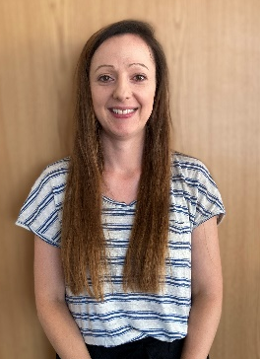

Nursery TA:
Mrs R Gallehdar (Full time)

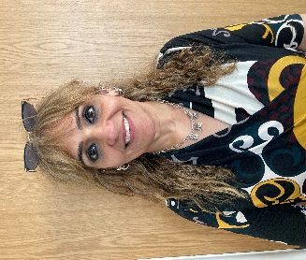

Damson Wood Nursery and Infant School
Stockwell Rise, Solihull, B92 9LX
0121 705 8652
www.damson-wood.co.uk
office@damon-wood.solihull.sch.uk – School Secretary: Mrs Z Jeffs

OUR SCHOOL VALUES

‘Learning and Growing Together’

Our pupils are taught an ambitious curriculum, covering a wide range of subjects, which supports and challenges everyone to increase their skills and knowledge over time and make sustained progress. We work particularly hard to ensure no child is left behind by providing equally high-quality learning opportunities for all our pupils, including those with SEND.

Our pupils are encouraged to successfully grow in their confidence, self-awareness and emotional intelligence. We focus on the whole child at Damson Wood and our hope is that children instil our core values, including safety, kindness and pride. We treat our children with care and respect and use consistent systems within a positive ethos to support children with their behaviour and to take care of their well-being.

Damson Wood is a close community with a shared vision to provide the best possible learning and growth opportunities for our children from when they arrive in Woodies Childcare to when they leave us to embark on their journey to junior school. Staff work in collaboration with parents to understand and support our pupils in the best way possible and this partnership is highly valued by all. Children come together in many different ways and learn to play and live together successfully.

The learning and growth our children experience at Damson Wood lays a strong and well-grounded foundation for children to continue to progress in the future.

We commit ourselves fully to ‘Learning and Growing Together’ at Damson Wood and this aspiration, underpinned by our core SPARKS values, drives all we do.

At Damson Wood Nursery and Infant School, we have 6 core values:
Safe
Proud
Ambitious
Ready
Kind
Successful

We introduce our values to the children at the beginning of their learning journey and continue to develop and embed these during their time with us.

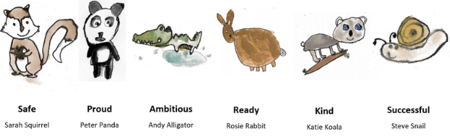

SCHOOL DAY

We open our doors at 8:30 am. Children must be in school by 8.45 am for registration. It is important that your child arrives by 8:45am otherwise they will miss vital learning time at the beginning of the day. Should your child be late, they must be brought to the school office to sign in and choose their lunch option. Lateness can impact on your child’s progress, mental well-being and can lead to a fixed penalty notice for unauthorised absence.

Children should be collected from their classroom door at 2:45 pm. Teachers will be releasing the children from the classroom doors ONLY when they can see the adult that has come to collect them and this can take some time. If you are unable to collect your child on time due to an unforeseen delay, please inform the school office as soon as possible. Also, if someone who is not a regular carer is collecting your child, please let your child’s Class Teacher or office staff know.

ATTENDANCE
At Damson Wood, we expect all our children to have excellent attendance and punctuality. Our school target for attendance is 96%. We reward the children who have ‘Good Attendance’ with Dojos, certificates and prizes. If your child’s attendance falls below this, the school Attendance Officer is likely to contact you to offer support and establish strategies to prevent further poor attendance. You also may be contacted or visited at home by our commissioned Education Welfare Officer through an organisation called CSAWS. This is also to support improving your child’s school attendance. Please bear in mind that 90% attendance means that your child has missed 4 weeks of learning in one year!

Top tips to promote good attendance:
· Inform us on the FIRST DAY if your child is absent.
· Tell us if your child is unhappy or worried – we will help!
· BE ON TIME EVERY DAY – the day starts 8.45 a.m.
· Book holidays during the school holidays, NOT during term time.
Term dates can be found on our school website.

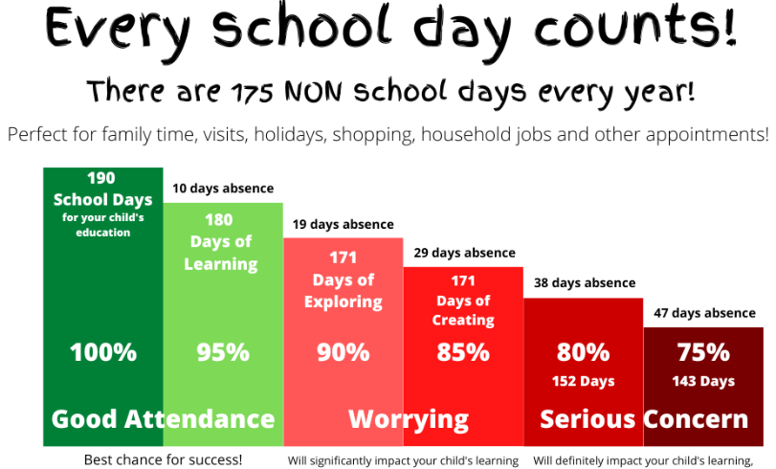

ABSENCE / STUDYBUGS

The best way to communicate absence to school is via Studybugs. Studybugs operates via a free app, or you can register on the Studybugs website, to tell us whenever your child is ill and unable to attend school. You will have received a letter to give you all the details you need about setting up and using Studybugs. If your child is absent from school for 3 days or more without an explanation the Education Welfare Officer will be informed.

Headteachers only have legal authority to grant leave of absence during the school term in exceptional circumstances. Absence Request Forms are available from the office for requesting any leave of absence from school; these should be completed and returned to school via the school office, giving at least 2 weeks’ notice. Holidays in term time will not be authorised.


CLASS DOJO / COMMUNICATION
Class Dojo is our school communication platform and reward system. Teachers, children, and families can access Class Dojo every day to build close-knit communities by sharing what’s being learned in the classroom and home through photos and videos. Please note that teachers are unable to reply to messages during school hours and after 6pm. Any urgent messages should always go via the school office.

PARENT / TEACHER LIASON
Teachers are always available to chat briefly to you at the beginning or end of the day or, if you have any concerns, you can make an appointment to see the teacher out of school hours.
During the year, there will be formal occasions when you will be invited to discuss your child’s progress (usually in October and February) with the Teacher. Parents are also invited to attend Sports Days, performances, celebration assemblies, etc. ParentPay e-mails or letters will be sent out to advise you of these events and the weekly school newsletter always has a list of up-to-date diary dates.

CURRICULUM
Each half term we will send home our project planners and knowledge organisers. These will outline what learning will take place over the half term and how you can help your child at home.



Autumn 1 – All About Me
Autumn 2 – Celebrations
Spring 1 – Bears
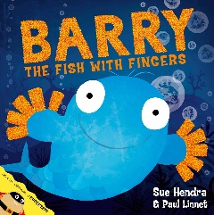

Spring 2 – How Does Your Garden Grow
Summer 1 – Down on the Farm
Summer 2 – Under the Sea

In Nursery, we follow the Early Years curriculum that covers 7 areas of learning: Communication and Language, Personal, Social and Emotional Development, Physical Development, Literacy, Mathematics, Understanding the World and Expressive Arts and Design

To enhance our curriculum, we have visitors in school, trips out to the local area and dress up days. We also take part in school wide events such as Anti bullying weeks and Science week.
We will notify you of these events throughout the year.
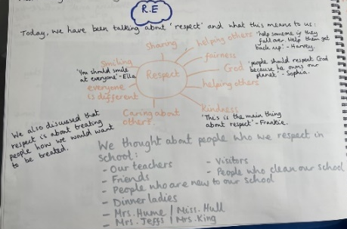
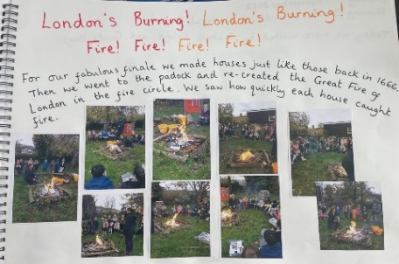

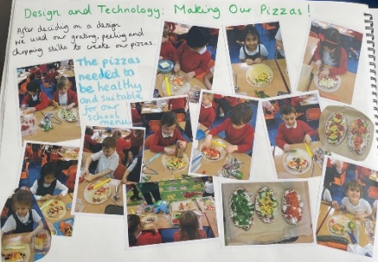
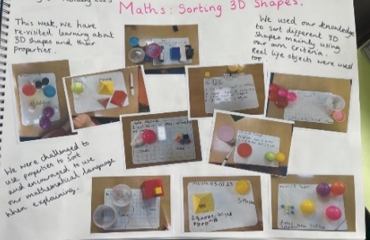

LITTLE WANDLE PHONICS & READING
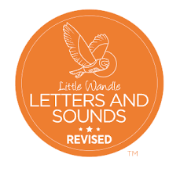
At Damson Wood we follow the Little Wandle Letters and Sounds Phonics scheme. We begin teaching children in Nursery the foundations of phonics by playing lots of games that support children’s oral blending and segmenting.

The children will also be given the opportunity to visit the library each Wednesday. It is important to be sure that books are returned to avoid being asked to replace them, or pay for a replacement, if they are lost.

PSHE
During our PSHE lessons, children are encouraged to voice their ideas and express their feelings. Our ‘Jigsaw’ topics allow the children to think about their relationship with each other, their own self-esteem and how they cope with changes. We discuss healthy living and ways in which we keep ourselves safe.

SKILLS BUILDER
Damson Wood works with The Skills Builder Partnership to ensure every learner has opportunities to build eight essential skills to support them now and in the future. Research has shown that building these eight essential skills can support the emotional wellbeing and academic success of children and young people, as well as preparing them for life beyond school.

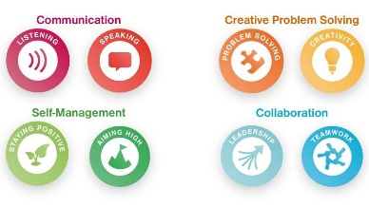
Essential Skills are defined as:
- Listening
- Speaking
- Problem solving
- Creativity
- Staying positive
- Aiming high
- Leadership
- Teamwork

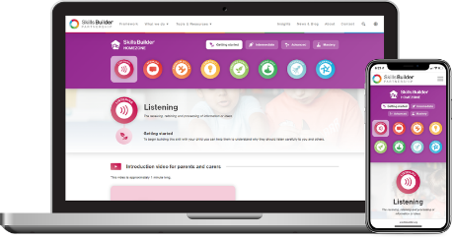
Skills Builder recognises the vital role parents and carers have in helping their children to build their essential skills. Skills Builder has made many of the resources we will be using in school to teach and practise skills available to use at home on the Skills Builder Home Learning Hub.

https://www.skillsbuilder.org/homezone

We will also be running a weekly Skills Challenge on our Home Learning Hub for learners to try at home. The challenges are designed to be fun, engaging and interactive and focus on building one skill each day. Families can sign up to receive the Skills Challenges by email via the Home Learning Hub.

HOME LEARNING & PADLET
Your child will have activities to complete at home to support their learning in school. These activities can be found on your child’s Year Group Padlet, which can be found here:

https://padlet.com/s19mmorris/nursery-home-learning-8myac6dadp75boms

SNACK FOR MORNING BREAK
The school has subscribed to the Government Fruit Scheme, operated by the National Health Service. This means that your child will receive a piece of fruit daily.

We encourage you to send in a named water bottle (no juice or squash please) to school each morning.

SCHOOL MEALS
Children in Nursery have the option to pay for a school lunch or bring in a packed lunch from home.
As some children in school have severe nut allergies, it is essential, if you do send in a packed lunch, that it does not contain any nuts or nut products, such as Nutella spread/bars.

MEDICATION
If your child needs medication you are welcome, if necessary, to come in and give this to your child. Staff may administer medicine (e.g. antibiotics) to your child, when it has been prescribed by a GP and only when a “Permission to Administer Medicines” form has been completed by a parent/carer. Staff may refuse to administer non-prescribed medicines due to potential allergies. Forms are available from the school office. Medicine should be sent in clearly named and with clear instructions. Staff will make every effort to give a child their medication, but the ultimate responsibility lies with parents.

If your child is asthmatic, please supply the teacher with a named inhaler with instructions on frequency of use, to keep in the classroom.

It is the parents’ responsibility to ensure that care plans are kept up to date, and that class teachers are informed of any changes to care plans. Medication, including Epipens, are kept in the school office. Please check regularly that there is sufficient medication and that it is still within its ‘use by’ date.

SCHOOL UNIFORM AND P.E. KIT

All of our children wear uniform to promote the identity of our school, to promote the feeling of community within the school and as a badge of pride. Our school uniform expectations ensure children are dressed appropriately for learning and play. We appreciate your support in upholding our uniform expectations.

Uniform embroidered with our logo can be purchased from:
Monkhouse Schoolwear Specialists, 1 Mell Square, Solihull, B91 3AZ

Forest School – Children wear waterproofs (either an all in one or trousers and raincoat) and wellies. This is for children who attend Nursery in the afternoon. Teachers will let you know when this will start.

Please mark EVERYTHING clearly with your child’s name. Although we encourage your child to look after their own belongings and as staff, we try our best to look after these, items of clothing especially jumpers and cardigans are easily muddled up so it is crucial that they are clearly labelled.

For safety reasons children are not allowed to wear jewellery of any kind in school. Pierced earrings are particularly dangerous and should not be worn under any circumstances. Please talk to the Headteacher if you belong to a religion that demands the wearing of jewellery as an essential and mandatory part of that faith. In the summer, children may wish to wear a sun hat or cap whilst outside.

Hair should be appropriate for school. Extreme hairstyles, colours and shaved patterns/lines are not permitted. Hair accessories should be in school colours (red, white, navy blue or black). Large bows or headbands are not allowed.

SPARE CLOTHES
Sometimes it might be necessary for the Nursery team to change your child’s clothes if they have had an accident. Please bring a spare pair of pants, socks, trousers and a top. This can be kept in school on their peg.

CONSUMABLES
Any consumables (i.e. nappies) are provided by parents.

BOOK BAG
Children carry home their reading books, library books, homework and any school letters in a red book bag with the school logo on. These can be ordered through ParentPay and collected from the office. Book bags are priced at £4.00. Please do not attach bulky key-rings to the book bag as they become stuck in drawers. Your child’s name on the outside of the bag is sufficient for identification. There is no need or room for children to bring large rucksacks to school.

ASSEMBLIES
Friday morning assembly is a celebration assembly and you are invited to attend when it is your child’s birthday or they are receiving an award. Your child’s birthday will be celebrated on the Friday after their birthday. Children may also be presented with a SPARKS certificate, Hot Chocolate Friday certificate or Skills Builder certificate. Children may also bring in awards from home to share with everyone.

Remember, sharing photos of your child on social media is your choice, but we must remind you to make sure there are no other children in any photos you share.

Please note that Nursery will join the Friday assembly when they have settled into school. This is usually after the Christmas Holiday.

BIRTHDAYS
We are aware that many parents like to celebrate their child's birthday in school as well as at home. Often this is done by sending in sweets to share with the rest of the class. However, parents may like to consider a healthier option and are invited instead to consider sending in a book for the book corner for the class to enjoy. Please note that we do not allow lollipops of any kind to be shared with the children because of health and safety reasons.

BIKES AND SCOOTERS
We encourage children to bike or scoot to school. However, can we please ask that these are stored in the main school bike park or taken home. They are not to be left in the Nursery garden as it is used every day for our outdoor learning.

HELP IN SCHOOL
We are always grateful for offers of help; however, parents/grandparents/carers must have DBS clearance (statutory safeguarding checks) through the school. We recommend that a DBS online application is completed at the beginning of the school year, so that when the need arises you may volunteer. Please see Mrs Jeffs in the School Office for details of how to apply. You can help in a variety of ways, perhaps in the classroom, working with a group or hearing readers.

WAYS YOU CAN HELP
- Ensure that your child arrives in school at 8:30am.
- Ensure that your child brings a water bottle to school daily.
- Work on skills that promote independence when changing clothing, like being able to turn a jumper or cardigan the right way around and learning to tie shoe laces.
- Make a list of what equipment is needed each day, so that your child can begin to take an increased responsibility for ensuring that they have their library book on the correct day.
- Take time to listen to your child read aloud to you and ask them questions about what they have read, using questions such as:
  - What do you think the story is about?
  - Why do you think that?
  - How is (the character) feeling? How do you know?
  - What does (unknown word) mean? –
  - What happened?
  - Why did … happen?
- Speak to us if you have any concerns/worries and we can be there to help you/your child.

AND FINALLY …

We look forward to welcoming your child and yourselves to what we hope will be another very happy and enjoyable year.

If you have any questions, please do not hesitate to contact your child’s class teacher.



