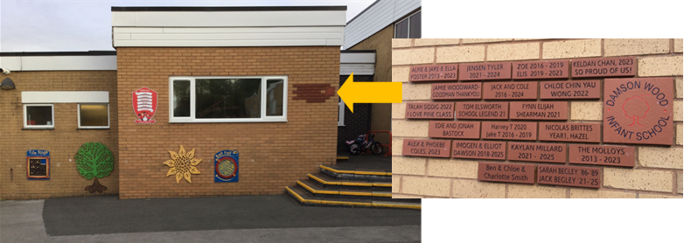
Leave a legacy at our school!

Buy a personalised brick and help create a space you and your child can be proud of, today and for the future.
Our permanent Wall of Fame by on the outside wall of the playground.

Create a lasting memory of your child’s infant school time
The personalised brick display offers a unique way to celebrate your connection to our school. Whether you choose to feature your name, your child’s or grandchild’s name, or a heartfelt message, each brick will serve as a lasting tribute to those who are part of our school’s story—past or present - all for £27.

To order: Please complete below order form and return electronically to: s19brick@damson-wood.solihull.sch.uk or hand in to our Front Office.
Payment through ParentPay. For multiple children and alumni, please email s19brick@damson-wood.solihull.sch.uk for bank details.
Order deadlines
Autumn: Thursday 23rd October 2025
Spring: Thursday 26th March 2026
Summer: Thursday 21st May 2026

Thank you for your continuing support,
Damson Wood Nursery & Infant School Academy

Buy A Brick Order Form - £27 per brick
Name:
Full Postal Address: | ______________________________________________________  ___________________________________ Post code: ________
Phone Number:
Email Address:
Child’s Name:
Child’s Class:

Brick Wording
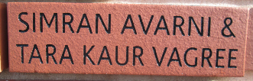
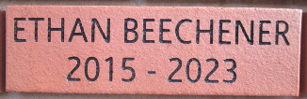
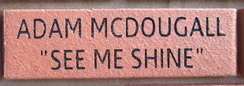
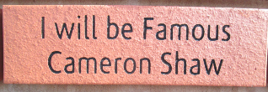
Each brick has space for 2 lines of text with a maximum of 16 characters per line. Punctuation and spaces count as characters.
For example:
Damson Wood Nursery & Infant School Academy reserve the right to reject wording that is felt to be inappropriate. Please check all spelling as we cannot be responsible for mistakes on this form.

