Reception Reading Challenge

Dear Parents and Children in Reception,
These reading recommendations consist of a variety of fiction and non-fiction books for all ability ranges and interests. We recommend these authors, but they are only a selection of the latest titles available. We would love to see more children reading books so if you find a book that you would like to recommend, send a book review our way! There’s a prize for anyone who reads every book on the list by the end of the year! Good Luck!
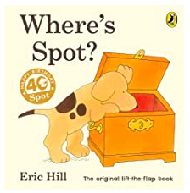
Where’s Spot by Eric Hill
Lift each flap to find all sorts of funny animal surprises, before discovering where cheeky Spot has been hiding.
That Rabbit Belongs to Emily Brown by Cressida Cowell and Neal Layton
A classic and catchy story of right and wrong that is perfect to explain the concepts of property and justice.
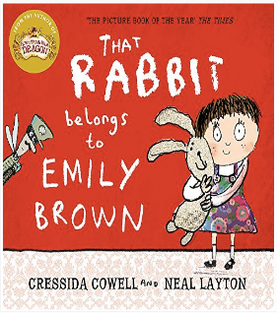

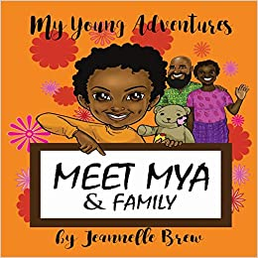
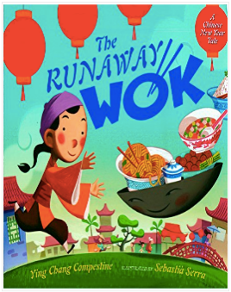
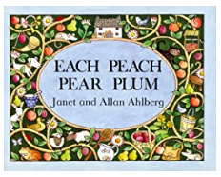
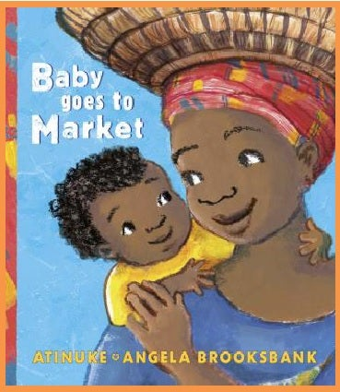
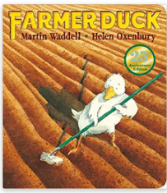
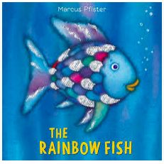
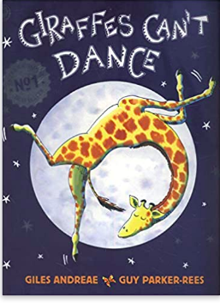
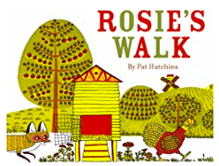
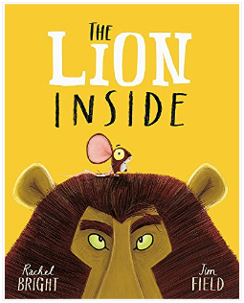
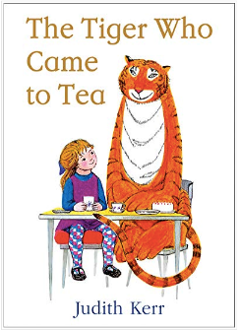
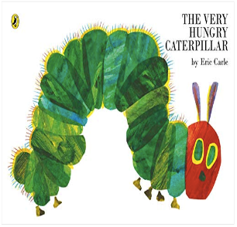
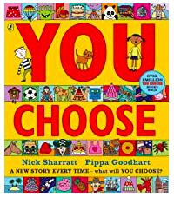
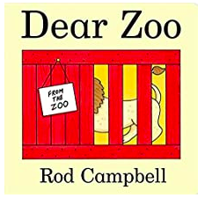
Meet Mya and Family by Jeanelle Brew
'Meet Mya & Family,' is the first of 'My Young Adventures' twelve book children's book series that introduces you to our protagonist, Mya, and her amazing family. Throughout 'Meet Mya & Family,' Mya guides us through a personal account of what she does and doesn't understand from observing her family members.
The Runaway Wok by Ying Chang Compestine
When a boy goes to the market to buy food and comes home with an old wok instead, his parents wonder what they’ll eat for dinner.
Each Peach Pear Plum by Allan and Janet Ahlberg
In this book, with your little eye, take a look and play ‘I spy’

You Choose by Pippa Goodhart
Imagine you could go anywhere, meet anyone and do anything. Where would you live? Where would you sleep? Who would be your friends? What games would you play? Go on…. you choose!

Farmer Duck by Martin Waddell
This is the story of a hardworking duck, who has the very bad luck of living with a lazy farmer. The duck cooks and cleans, tends the fields and cares for all the other animals on the farm – and all while the farmer lies in bed! When will out duck get a day off?
Rosie’s Walk by Pat Hutchins
One disaster after another befalls the poor fox while Rosie goes on her way, supremely unaware of the danger behind her.
Giraffes Can’t Dance by Giles Andreae
Gerald the tall giraffe would love to join in with the other animals at the Jungle Dance, but everyone knows that giraffes can’t dance…. Or can they?
The Very Hungry Caterpillar by Eric Carle
A beautifully illustrated story of a caterpillar eating his way through the book.
The Lion Inside by Rachel Bright
In a dry dusty place where the sand sparkled gold, stood a tiny mighty flat rock, all craggy and old. And under that rock is a tinyful house, lived the littlest, quietest, meekest brown mouse.
The Rainbow Fish by Marcus Pfister
Rainbow Fish will enchant even the youngest child with his silver scales and heart of gold in this award-winning book about the beautiful fish who learned to share his most prized possession.
Baby Goes to Market by Atinuke
This books tells the story of baby and Mama as they explore the bustling marketplace in their hometown.
The Tiger who came to Tea by Judith Kerr
When the doorbell rings during Sophie’s tea time, there’s a big striped tiger at the door. And he’s VERY, VERY hungry!
Dear Zoo by Rod Campbell
Love lifting the flaps to discover the animals the Zoo has sent – a monkey, a lion and even an elephant! But will they ever manage to send the perfect pet?
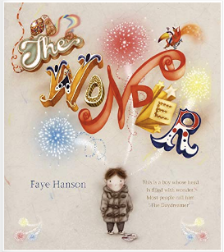
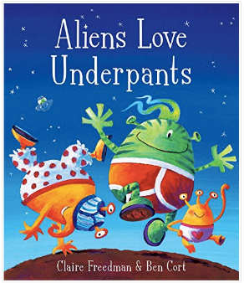
The Wonder by Faye Hanson
This is a boy whose head is filled with wonder. Most people call him ‘The Daydreamer’.
Aliens Love Underpants by Claire Freedman
Aliens love underpants, in every shape and size. But there are no underpants in Space, so here’s a big surprise!

Guess How Much I Love You by Sam McBratney
Sometimes, when you love someone very, very much, you want to find a way of describing how much you treasure them. But, as Little Nutbrown Hare and Big NutBrown Hare discover, love is not always an easy thing to measure.

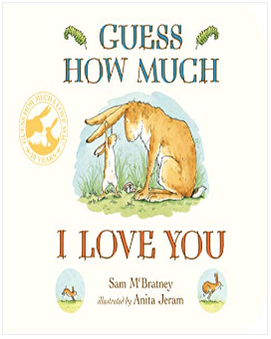
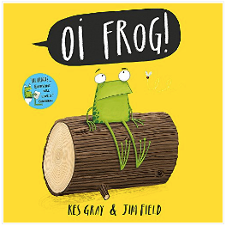
OI FROG by Kes Gray and Jim Field
Cats sit on mats, hares sit on chairs, mules sit on stools and gophers sit on sofas. But Frog does not want to sit on a log!

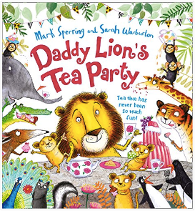
Hands Up! By Breanna J. McDaniel
A young black girl lifts her baby hands up to greet the sun, to reach for a book on a high shelf, and in praise at a church service. As she grows, she lives through everyday moments of joy, love, and sadness.

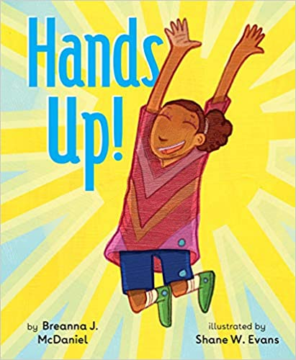
Daddy Lion’s Tea Party by Mark Sperring and Sarah Warbuton
Tea time has never been so much fun!

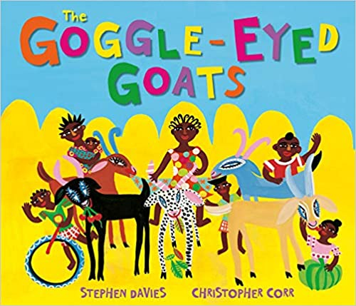
The Goggle-Eyed Goats by Stephen Davies A vibrant and colourfully illustrated tale about Old Al Haji Amadu's five extremely naughty and very hungry goats who gobble and gulp through whatever they find.
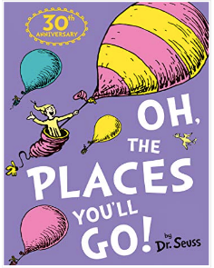
Oh the Places You’ll Go by Dr. Seuss
Congratulations! Today is your day. You’re off to Great Places! You’re off and away.

Good Night Moon by Margaret Wise Brown
In a great green room, a little bunny is tucked up snugly and safely in bed and is getting ready to say goodnight to all the familiar things in this room, one by one,
Pumpkin Soup by Helen Cooper
Cat, Duck and Squirrel live in an old white cabin, with a pumpkin patch in the garden. Every day Cat slices up some pumpkin, Squirrel stirs in some water and Duck tips in some salt to make perfect pumpkin soup…. until the day Duck wants to do the stirring.
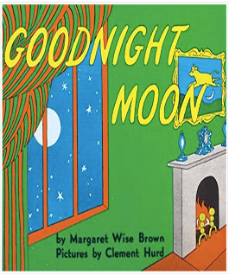
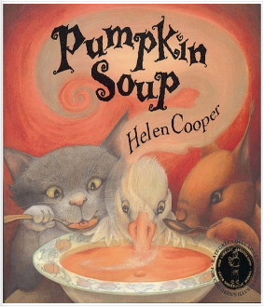

Not Now, Bernard by David McKee
Bernard’s got a problem. He’s found a monster in the back garden, but his mum and dad are just too busy to notice. So, Bernard tried to befriend the monster… and that doesn’t go quite to plan.
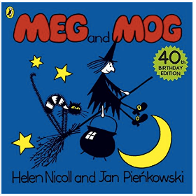
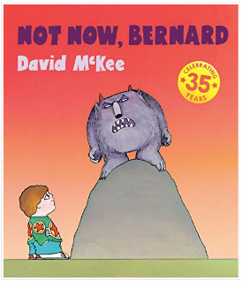
Meg and Mog by Helen Nicoll and Jan Pienkowski
In this classic tales, Meg the witch and Mog her cat go off to a wild Halloween party with all the other witches.

Mira’s Curly Hair by Maryam al Serkal
Mira doesn't like her hair. It curls everywhere! She wants it to be straight and smooth, just like her Mama's. But then something unpredictable happens . . . and Mira will never look at her mama's hair the same way again!
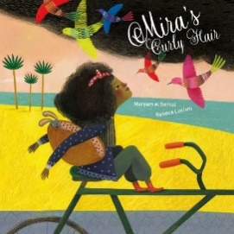
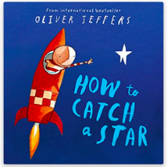
How to Catch a Star by Oliver Jeffers
An inspirational story of a boy who loved the stars so much, he decided to catch one of his very own.

Reception Challenging Reads

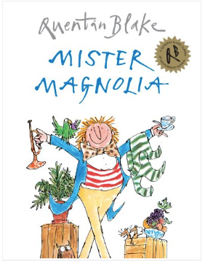
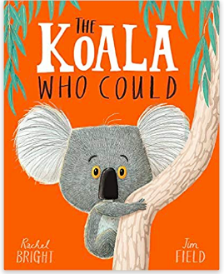
The Koala Who Could by Rachel Bright
Meet Kevin. A Koala who likes to keep things the same. Exactly the same, but sometimes change comes along whether we like it or not.

Mister Magnolia by Quentin Blake
A fun and engaging rhyming book about Mister Magnolia, a man who is missing a few things, before, in a happy ending, he received an unexpected parcel.

There’s a Lion in my Cornflakes by Michelle Robinson
Have you ever collected coupons from a cereal box? Maybe you were saving them up for a book or a toy. Well, how about saving up 100 coupons in exchange for a real Lion!

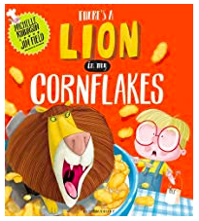
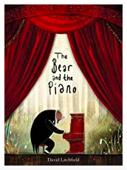
The Bear and the Piano by David Litchfield
A young bear stumbles upon something he has never seen before in the forest. As time passes, he teaches himself how to play the strange instrument, but will anyone be able to hear him?

