Year 1 Reading Challenge

Dear Parents and Children in Year 1,
These reading recommendations consist of a variety of fiction and non-fiction books for all ability ranges and interests. We recommend these authors, but they are only a selection of the latest titles available. We would love to see more children reading books so if you find a book that you would like to recommend, send a book review our way! There’s a prize for anyone who reads every book on the list by the end of the year! Good Luck!
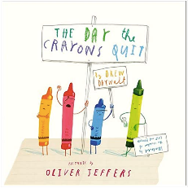
That Rabbit Belongs to Emily Brown by Cressida Cowell and Neal Layton
A classic and catchy story of right and wrong that is perfect to explain the concepts of property and justice.
The Day the Crayons Quit by Drew Daywalt
When Duncan opens his box of crayons, instead of colours, he sees letters spelling ‘’We Quit!’’ A very funny story which will appeal to all readers.
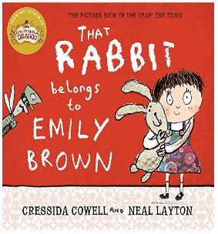

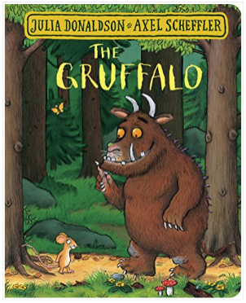
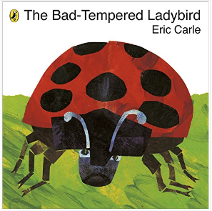
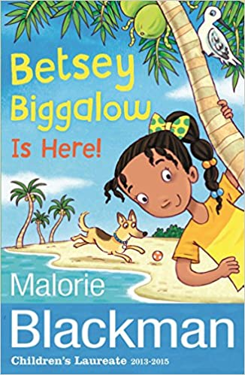
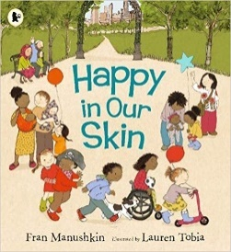
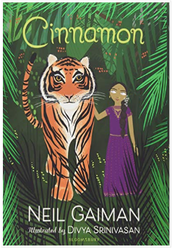
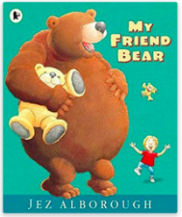
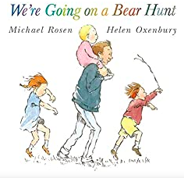
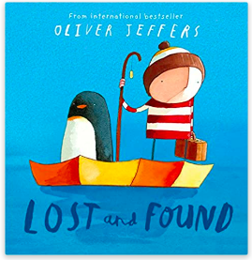
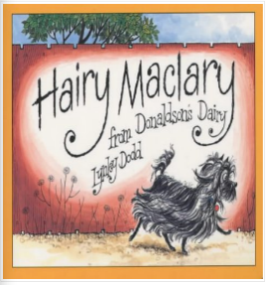
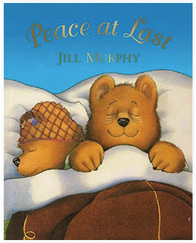
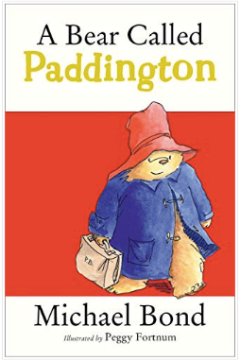
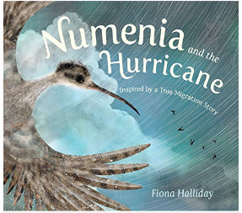
The Gruffalo by Julia Donaldson
A modern classic about a mouse who escapes the clutches of various other animals who want to eat him by creating a monster who is more scary than all of them put together.
The Bad-Tempered Ladybird by Eric Carle
This short story is about a ladybird who argues with every other living creature he meets. This ideal book for year 1 children also uses a clock face cleverly to illustrate the passing hours.

Betsey Biggalow is Here!
By Malorie Blackman
Betsey Biggalow may be small but she's full of bright and shiny ideas about new trainers, winning at marbles and even helping the world! Join Betsey on four short, sun-filled adventures as she learns you don't have to be big to make a big difference.
A Bear Called Paddington by Michael Bond
The classic tale of Paddington, a bear from Darkest Peru, who joins the Brown family with nothing but a hat, a suitcase and a jar of marmalade.
My Friend Bear by Jez Alborough
Eddy and the Bear are both feeling sad, they both wish they had a friend to talk to. All they’ve got are their teddies, and teddies can’t talk. Or can they?
Happy in our Skin by Fran Manushkin
A delightfully rhythmical read-aloud text is paired with bright, bustling art in this joyful exploration of the new skin of babyhood. All children can see themselves, and open their eyes to the world around them, in this sweet, scrumptious celebration of skin in all its many, many, wonderful forms.
Cinnamon by Neil Gaiman
A stunning modern fable with vibrant illustrations. Cinnamon is a mysterious princess who has pearls for eyes, cannot see and does not speak. While many people try to help her, but none succeed – until a fearsome tiger befriends her and changes her life forever.

Peace at Last by Jill Murphy
A funny story about Mr Bear’s desperate attempts to find a quiet place to sleep. Wherever he goes and whichever room he tries, there’s an annoying noise.
Lost and Found by Oliver Jeffers
There once was a boy and one day a penguin arrives on his doorstep. The boy decided the penguin must be lost and tries to return him. But no one seems to be missing a penguin. So the boy decides to take the penguin home himself, and they set out in his row boat on a journey to the South Pole.

We’re going on a Bear Hunt by Michael Rosen
Follow and join in the family’s excitement as they wade through the grass, splash through the river and squelch through the mud in search of a bear. What surprises await them?

Hairy Maclary from Donaldson’s Dairy by Lynley Dodd
Hairy Maclary likes to wander off for a walk with his friends. But the scary Scarface Claw is just around the corner.
Numenia and the Hurricane by Fiona Halliday
A touching picture book story that follows a young bird who struggles against the elements to find and re-join her family.
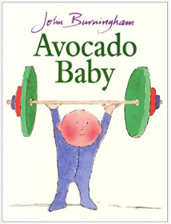
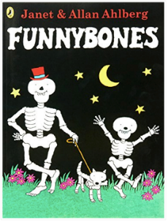
Avocado Baby by John Burningham
When the Hargreaves family let their child eat an avocado, very strange and inexplicable things start to happen. A great book for children to use to develop imaginative ideas.
Funnybones by Allan Ahlberg
A family of skeletons and their dog set out to scare people in the night. But when they find everyone is asleep, they decide to scare themselves instead, with lots of silly jokes.

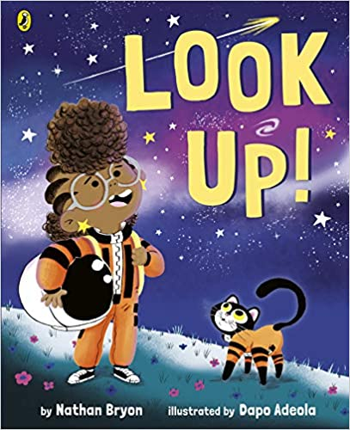
Look Up! By Nathon Bryon
Meet hilarious, science-mad chatterbox, Rocket - she's going to be the greatest astronaut, star-catcher, space-traveller that has ever lived! But... can she convince her big brother to stop looking down at his phone and start LOOKING UP at the stars?

Kechi's Hair Goes Every Which Way

By Tola Okogwu

Kechi's hair is big, thick and loud ... and that's just the way she likes it. Mummy's away and it's up to Daddy to get Kechi and her hair ready for school. There's just one problem... he doesn't know how!

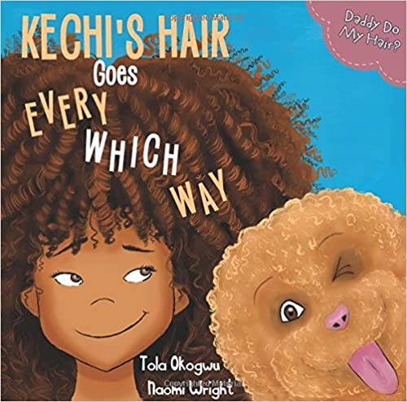

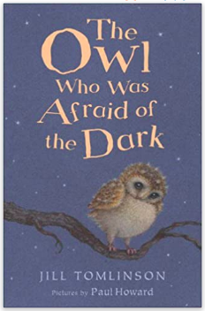
The Owl Who Was Afraid of the Dark by Jill Tomlinson
Plop, the Baby Barn Owl, is like every Barn Owl there ever was, except for one thing – he is afraid of the dark. ‘Dark is nasty’, he says and so he won’t go hunting with his parents or leave the nest.

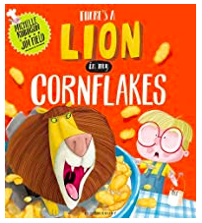
There’s a Lion in my Cornflakes by Michelle Robinson
Have you ever collected coupons from a cereal box? Maybe you were saving them up for a book or a toy. Well, how about saving up 100 coupons in exchange for a real Lion!

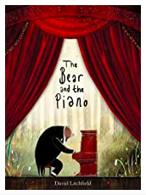
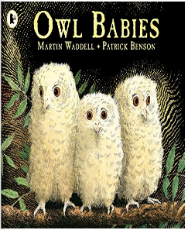
Owl Babies by Martin Waddell
Three baby owls wait for their mother to come and wonder where she is. They wait and wait, and it becomes darker and darker, and in a happy ending, the mother returns.
The Bear and the Piano by David Litchfield
A young bear stumbles upon something he has never seen before in the forest. As time passes, he teaches himself how to play the strange instrument, but will anyone be able to hear him?

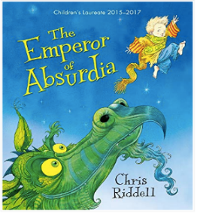
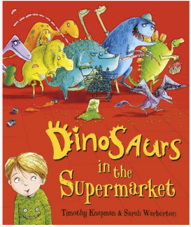
Dinosaurs in the Supermarket by Timothy Knapman
Be warned! A trip to the supermarket will never be the same after your child has read this outrageously funny and addictive rhyming story.
The Emperor of Absurdia by Chris Riddell
A wonderfully illustrated fantasy story about a strange world of wardrobe monsters, snoring fish; with a clever twist ending.

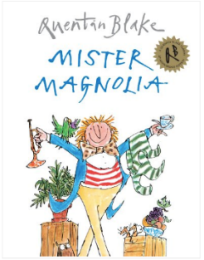
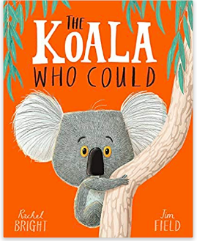
The Koala Who Could by Rachel Bright
Meet Kevin. A Koala who likes to keep things the same. Exactly the same, but sometimes change comes along whether we like it or not.
Mister Magnolia by Quentin Blake
A fun and engaging rhyming book about Mister Magnolia, a man who is missing a few things, before, in a happy ending, he received an unexpected parcel.

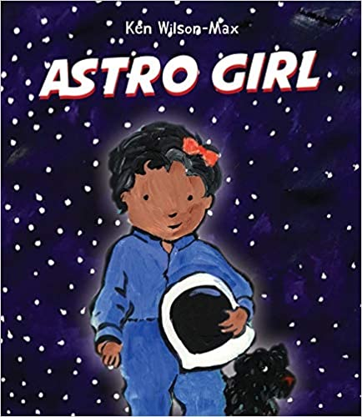
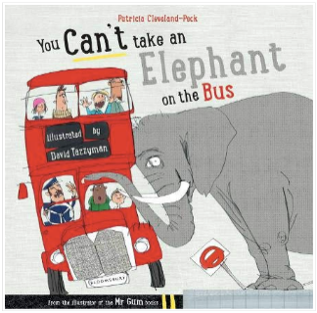
Astro Girl by Ken Wilson-Max
Astrid has always loved the stars and space. While Mama is away, Papa and Astrid have fun acting out the challenges an astronaut faces on a space mission - Astrid can do it all! Then it's time to meet Mama at the airbase. But where has Mama been?
You Can’t Take an Elephant on the Bus by Patricia Cleveland-Peck
A hysterically funny rhyming picture book where a variety of unlikely animals cause complete chaos.

Year 1 Challenging Reads

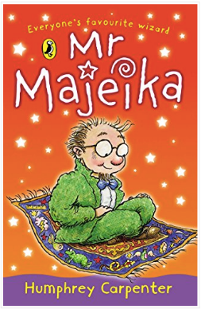
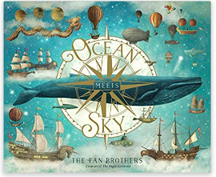
Mr Majeika by Humphrey Carpenter
Mr Majeika is no ordinary teacher. He arrives each day by magic carpet and turns the class clown into a frog. School is never the same again.

Ocean Meets Sky by Eric Fan
Finn lives by the sea and the sea lives by him. Every time he looks out his window it’s a constant reminder of the stories his grandfather told him about the place where the Ocean meets the sky.

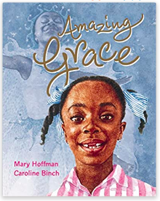
The Hodgehed by Dick King-Smith
Max is a hedgehog who live with his family in a nice little home, but it’s on the wrong side of the road from the Park where there’s a beautiful lily pond and plenty of juicy slugs, works and snails. The busy road is dangerous, but Max is determined to make his way across. If humans can do it, why can’t hedgehogs?

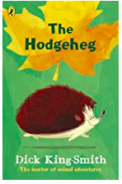
Amazing Grace by Mary Hoffman
Grace loves to act out stories. Sometimes she plays the leading part, sometimes she is ‘a cast of thousands.’ When her school decides to perform Peter Pan, Grace is longing to play Peter but her classmates say that Peter was a boy, and besides, he wasn’t black.

