Year 2 Reading Challenge

Dear Parents and Children in Year 2,
These reading recommendations consist of a variety of fiction and non-fiction books for all ability ranges and interests. We recommend these authors, but they are only a selection of the latest titles available. We would love to see more children reading books so if you find a book that you would like to recommend, send a book review our way! There’s a prize for anyone who reads every book on the list by the end of the year! Good Luck!
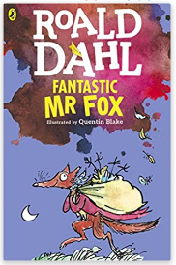
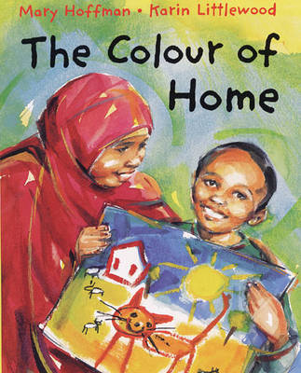
Fantastic Mr Fox by Roald Dahl
Mr Fox is so clever that every evening he creeps down into the valley and helps himself to food from many farms and those ghastly farmers can’t catch him…. or can they?

The Colour of Home by Mary Hoffman
This is a warm, ultimately hopeful story about the world of a refugee child, and the compassion and understanding shown to him by his teachers and schoolmates.

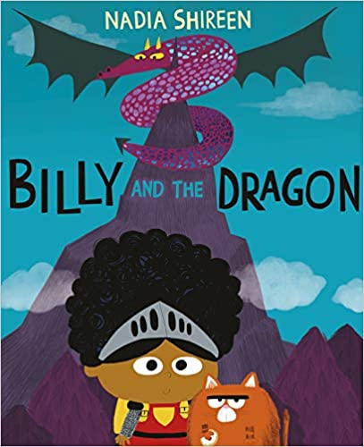
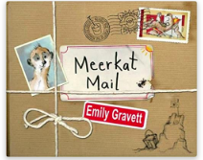
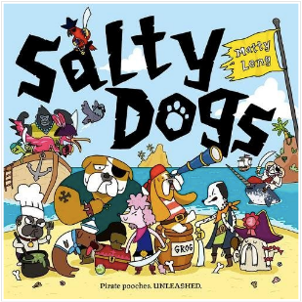
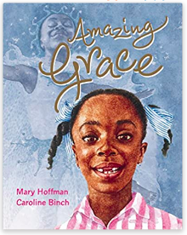
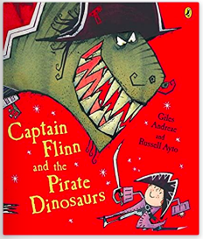
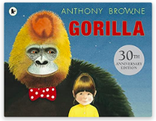
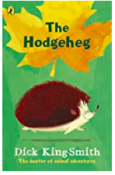
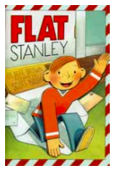
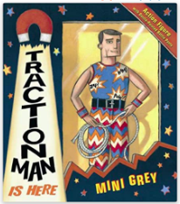
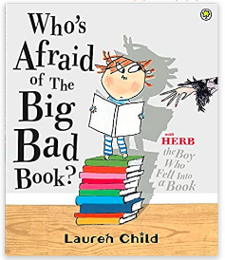
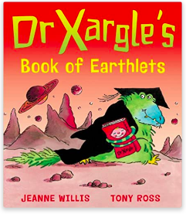
Billy and the Dragon by Nadia Shireen
Whilst at a fancy-dress party, something terrible happens: Billy's loyal sidekick Fatcat is kidnapped by a fire-breathing dragon. Uh-oh! But luckily for Fatcat, Billy won't stand for that: off she goes on a brave rescue mission...

Gorilla by Anthony Browne
Hannah loves gorillas but has never seen one. Her father’s too busy to take her to the zoo – or for anything else come to that. For her birthday, Hannah asks her father for a gorilla, she is disappointed when she discovers it is a toy one but then something extraordinary happens….

Amazing Grace by Mary Hoffman
Grace loves to act out stories. Sometimes she plays the leading part, sometimes she is ‘a cast of thousands.’ When her school decides to perform Peter Pan, Grace is longing to play Peter but her classmates say that Peter was a boy, and besides, he wasn’t black.
Meerkat Mail by Emily Gravett
Sunny the meerkat lives with his enormous family in the Kalahari Desert. They are all very close… so close, in fact, that one day Sunny decided he’s had enough and packs his bags. Where will he go and what will he see?
The Hodgeheg by Dick King-Smith
Max is a hedgehog who live with his family in a nice little home, but it’s on the wrong side of the road from the Park where there’s a beautiful lily pond and plenty of juicy slugs, works and snails. The busy road is dangerous, but Max is determined to make his way across. If humans can do it, why can’t hedgehogs?

Salty Dogs by Matty Long
The Salty Dogs are a band of pirates constantly on the lookout for riches and treasure. Along the way, they meet outrageous sea monsters and a shop full of monkeys.
Captain Flinn and the Pirate Dinosaurs by Goles Andreae
Flinn is at school looking in the art cupboard for some coloured pens to finish off his dinosaur drawing when he stumbles upon Captain Stubble, a real live Captain! He tells Flinn that his ship, the Acorn, has been stolen and he needs Flinn to help him rescue it back.
Dr Xargle’s Book of Earthlets by Tony Ross
‘’Good Morning Class, today we are going to learn about Earthlets.’’
In this way, Dr Xargle, our friendly alien teacher, begins to teach his class about humans and babies. This is a hysterically funny book, with a particularly wry look at the way we bring up babies: look out for the ‘egg-mangle’. Will you ever want to eat egg again?

Who’s Afraid of the Big Bad Book? By Lauren Child
Now if you were going to fall into a book, a book of fairy tales would probably not be your first choice. Because in every story there is always a wicked this, an evil that or a hungry somebody. It could only happen to Herb, Beware of the Storybook Wolves.
Traction Man is Here by Mini Grey
With an action outfit for every occasion, Traction Man patrols the house. Whether he is saving toys, searching the sink for the lost wreck of the sieve or rescuing damsels in distress, Traction Man is never less than stylishly turned out and expertly accessorised.
Flat Stanley by Jeff Brown
Stanley Lambchop was just an ordinary boy – until a noticeboard fell on him. Now he is as flat as a pancake! Being flat is fantastic – he can be rolled up, sent in the post and even fly like a kite. But it’s not all fun and games…. There are thieves in town. Can Flat Stanley be the hero?

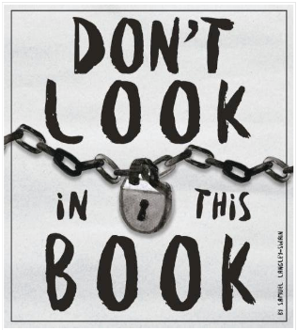
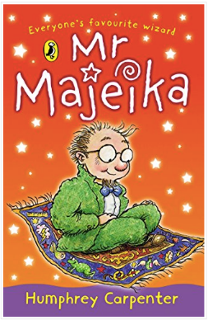
Mr Majeika by Humphrey Carpenter
Mr Majeika is no ordinary teacher. He arrives each day by magic carpet and turns the class clown into a frog. School is never the same again.
Don’t Look in this Book by Samuel Langley-Swain
With an eye-catching cover and provocative title, this book is bound to appeal to reluctant readers. The artwork takes the reader on an imaginative journey through fantastical places including outer space and a luminous green sewer.

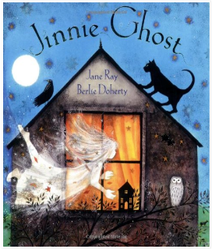
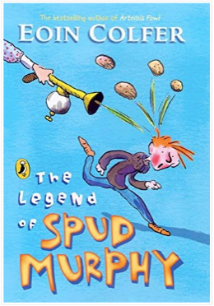
Jinnie Ghost by Berlie Doherty
A captivation poem about Jinnie, a ghost who only exists in the daytime, who makes Charlotte’s toys come to life and creates a giant who leads an expedition to a castle in the clouds.
The Legend of Spud Murphy by Eoin Colfer
Not only does Will struggle to get any attention with four other brothers in the house, his mother decided to send them all to the library – in the holidays! The Librarian, Spud Murphy, is Will’s worst nightmare!

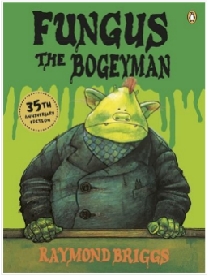
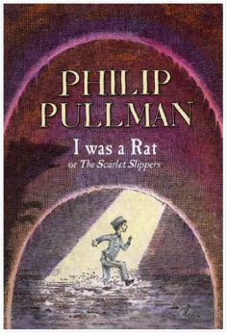
I was a Rat or, the Scarlet Slippers by Philip Pullman
A little boy turns up on the doorstep of Old Bob and his wife Joan, and when asked where he came from, says ‘I was a rat!’
An enthralling story with a clever twist.
Fungus the Bogeyman by Raymond Briggs
Full of snot, slime, smells and much revoltingness! This book is bound to appeal to reluctant readers and give the whole family a giggle.

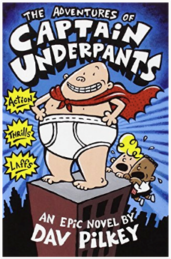
The Adventures of Captain Underpants by Dav Pilkey
Two boys hypnotise their head teacher and create an alter ego – Captain Underpants – with wedgie power – fighting for good against evil!
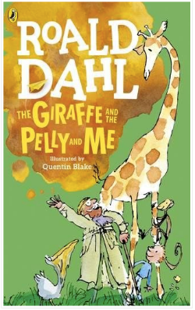
The Giraffe and the Pelly and Me by Roald Dahl
A crazy story about Billy, who wants to own a sweet shop, and the Ladderless Window Cleaning Company run by a giraffe, a Pelly and a monkey!

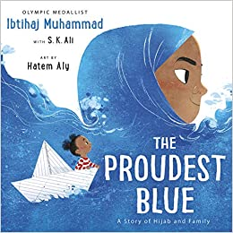
The Proudest Blue by Ibtihaj Muhammed
This is an uplifting, universal story of new experiences, the unbreakable bond shared by siblings and of being proud of who you are, from Olympic medalist Ibtihaj Muhammad.

Uncle Gobb and the Dread Shed by Michael Rosen
Malcolm is a normal boy, but all those around him are slightly strange. There’s a school that tries hard to make everything boring, a genie who appears if you rub your nose, and a city called Ponky!

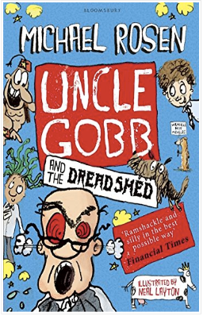
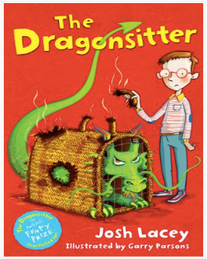
The Dragonsitter by Josh Lacey
Young Edward has been asked to look after his uncle’s pet while he goes on holiday. But it’s no ordinary pet, it’s a dragon – who eats Jemima!

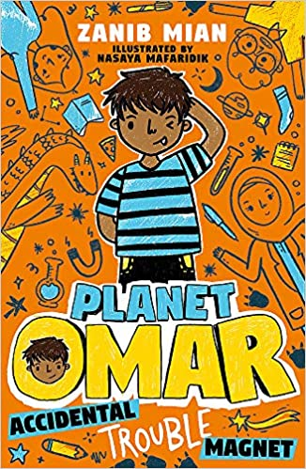
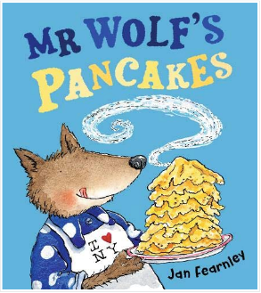
Accidental Trouble Magnet by Zanib Mian
Welcome, readers, to the imaginative brain of Omar! You might not know me yet, but once you open the pages of this book you'll laugh so hard that snot will come out of your nose (plus you might meet a dragon and a zombie - what more could you want?).
Mr Wold’s Pancakes by Jan Fearnley
Traditional fairy tales, such as Little Red Riding Hood and The Three Little Pigs are reworked in these extremely funny stories about a wolf who has some trouble making pancakes.

Year 2 Challenging Reads

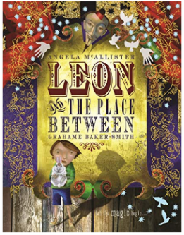
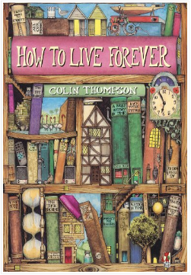
Leon and the Place Between by Angela McAllister and Grahame Baker-Smith
Leon finds out what happens to the rabbit which appears from a hat and where the magician’s assistant disappears to – but can he find his way back from the ‘place between’?

How to Live Forever by Colin Thompson
A unique and imaginative book about Peter, who lives in a magical library and Is on the search for a very special book entitles:
‘’How to Live Forever’’.

Sam Wu is Not Afraid of the Dark by Katie and Kevin Tsang
Sam has proved that he is the bravest kid in his school (although his sworn enemy Ralph still calls him ‘Scaredy-Cat Sam’). Now it’s up to him to protect everyone against all types of attacks and survive the class camping trip.
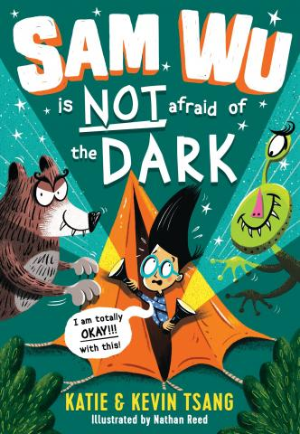
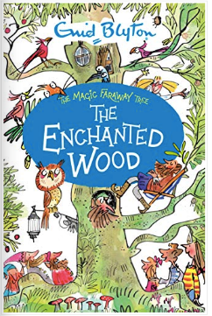
The Enchanted Wood by Enid Blyton
Could you choose between the Land of Birthdays and the Land of Toys? This is a classic and captivating story set in a magical land!

