

Damson Wood Forest School Progression Map
National Curriculum Coverage

Whole School Progression Overview |  | Autumn 1 | Autumn 2 | Spring 1 | Spring 2 | Summer 1 | Summer 2
Whole School Progression Overview | Nursery |  |  |  |  | Boundaries and Rules  In this unit, children will learn where the boundaries of Forest School are and how to prepare and dress for visits to Forest School | Games  In this unit, children will learn simple games that can be used to settle into the Forest School area, such as 1,2,3, Where Are You and Guess What?!
Whole School Progression Overview | Reception | Games  In this unit, children will learn simple games that can be used to settle into the Forest School area such as What Am I? and Nature Alphabet. | Shelters  In this unit, children will learn about materials which can be found in the Forest School area that can make good shelters. | Warmth  In this unit, children will learn about how to stay warm, changes in the weather and materials for insulation. | Plants  In this unit, children will learn how plants grow, make vegetable beds, sow seeds, harvest. | Materials  In this unit, children will learn about how different materials can keep them warm and safe outdoors. | Food – Harvest and Cooking  In this unit, children will learn how seeds need space, sunlight and water to help them grow.
Whole School Progression Overview | Year One | Games  In this unit, children will learn simple games that can be used to settle into the Forest School area such as Nature Walk (senses walk), Who Am I?! and Make a Sentence. and Story Telling or Journey Sticks. | Knots and Structures  In this unit, children will learn how to secure rods for structures and basic shelters. | Fire Lighting – Fire Lighters  In this unit, children will learn rules of the fire pit, how to construct a fire pit area, materials to make a spark and light a fire, how to store ignitable materials. | Plants  In this unit, children will learn how to maintain veg beds and what plants needs to grow. | Tools  In this unit, children will learn how to use simple tools such as potato peelers to make skewers for toasting foods on a fire. | Tools – continued & Food – Harvest and Cooking  In this unit, children will learn how to plant, grow and harvest their crops, how to cook them on the campfire to make roasted vegetables.
Whole School Progression Overview | Year Two | Games  In this unit, children will learn simple games that can be used to settle into the Forest School area such as What Am I?!, Feely bag descriptions and Story Telling or Journey Sticks. | Knots and Structures  In this unit, children will learn more complex knots that can help to bear weight for self-supporting structures. | Fire Lighting – Building a Camp Fire  In this unit, children will learn how to build and manage a small fire, how to extinguish a fire. | Plants  In this unit, children will learn about pollination and co-planting. | Tools  In this unit, children will learn how to construct a carved item (animals). | Food Continued & Food – Harvest and Cooking  In this unit, children will learn how to harvest co-planted crops, leave their vegetable beds ready for winter and cook their vegetables to make campfire fajitas.

Our Quality of Education – Year Nursery – Forest School
Autumn 1 | Project – All About me!  In this project children will:  Key Vocabulary:  Key Learning for Children to Remember:  Children will explore Forest School when they are settled and ready to access (likely summer 1).
Autumn 2 | Project – Celebrations  In this project children will:  Key Vocabulary:  Key Learning for Children to Remember:
Spring 1 | Project – Bears  In this project children will:  Key Vocabulary:  Key Learning for Children to Remember:
Spring 2 | Project – How does your garden grow?  In this project children will:  Key Vocabulary:  Key Learning for Children to Remember:
Summer 1 | Project – Down on the Farm  In this project children will: Learn how to prepare for a visit to Forest School and how to dress independently for the weather. Children will take a short visit to the paddock to find out where it is and to learn the three rules – no picking (live items), no licking (nothing in your mouth) and to walk around the outside of the seated area to prepare for camp fire.  Explore mud kitchen and making own natural paint using mud and mud kitchen resources.  Key Vocabulary: pick, lick, safe, boundary, forest, kit, wellies, waterproof, coat, hat, sun cream, gloves,  Key Learning for Children to Remember: The three rules of forest school and how to dress for a visit.  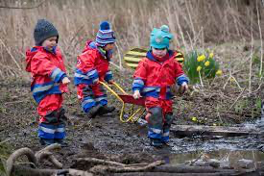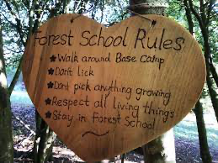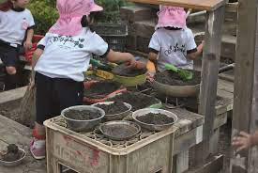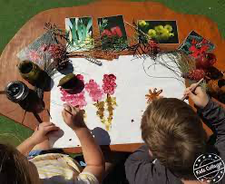
Summer 2 | Project – Under the Sea  In this project children will: Learn some of the basic games we can play in forest school –  1, 2, 3, Where Are You?  In this game, children will be given a countdown from 10 to find a safe and suitable place to hide. Once the adult has counted, they can move around the paddock to try and find all of the children. When the adult shouts 1, 2, 3, Where Are You? the children must come out of hiding and return to the fire circle. This game is to build trust and to follow basic rules in case of emergency.  Guess What?!  In this game (much like I Spy), children can work in small groups or as a large group. One person has to spot something in the paddock and give a clue as to what they are thinking of. Children can ask questions to find out more and guess what it is. The person who guesses what it is will be the next to spot an item.  Key Vocabulary: 1, 2, 3, Where Are You? return, base camp, fire circle, return, sit, rules, describe, woodland items.  Key Learning for Children to Remember When the adult calls 1, 2, 3, Where Are You, you must return to base camp immediately.  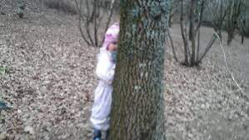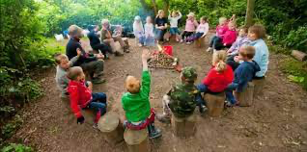

Our Quality of Education – Year Reception – Forest School
Autumn 1 | Project - Ahoy There! In this project children will: Learn that different materials can be used to make structures – some are more useful and reliable than others. Materials can be used for their properties to build structures – e.g. strong, bendy etc.  Lesson 1: Identify shapes in natural objects – which will fit together and which won’t? Which can be strong and which are weak?  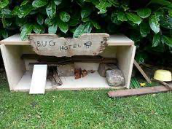  Deeper: Understand that the shape and size of materials affect how strong or weak it is, e.g. a branch could be strong or weak depending on how thick and long it is.  Lesson 2: Compare homes and habitats of different mini-beasts – do they all like the same type of home? Why/not? What are the benefits of their home? Is it dark, is it protected by strong materials?  Deeper: Understand why habitats are made in one location and why another location is not suitable – e.g. ants underground hill is better than on a tree stump because they are small and might be crushed.  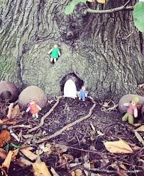  Lesson 3: Constructing different sizes structures – practicing using natural materials to build a structure that could hold the weight of a small animal/teddy bear.  Deeper: Explain what type of animal their structure would be good for and able to explain why.  Key Vocabulary: wood, grass, metal, plastic, glass, bendy, strong, hard, soft, weak, secure.  Key Learning for Children to Remember:  - Different materials will be found in different areas, animals will have preferences and build their homes in those places.
Autumn 2 | Project – Potion Commotion: In this project children will: Learn that the weather changes in winter and that animals and humans need to stay warm to protect themselves from the colder weather.  Lesson 1: Ways to stay warm in the winter – what activities help your body to stay warm? Comparison of fast-moving activities and more sedentary activities.  Deeper: Understand that more vigorous activities make the heart beat faster and pump warm blood around the body to keep warm.  Lesson 2: Identify the changes seen in winter – what looks different out in forest school now that it is winter? What is the same?  Deeper: Link to evergreen and deciduous trees, deciduous trees lose their leaves.  Lesson 3: Explore materials that are useful to keep you warm in winter – which are most useful? Explore a range from paper, cardboard box, cotton, fleece blanket, waterproof raincoat.  Deeper: Which is better for different weathers?  Key Vocabulary: weather, snow, rain, wind, cold, temperature, dark, daylight.  Key Learning for Children to Remember:  - Different materials will be found in different areas, animals will have preferences and build their homes in those places.  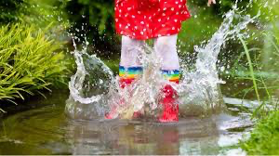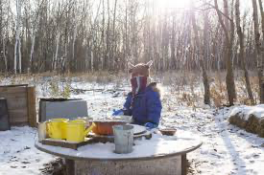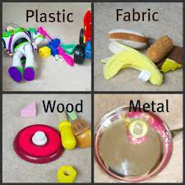
Spring 1 | Project – Stones and Bones - In this project children will: Learn about naturally occurring materials in the woodland area, choose materials for their protective properties.  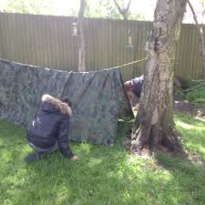  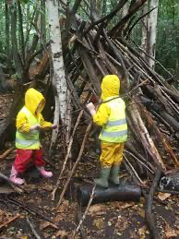  Lesson 1: Finding materials – what is out in the paddock? What do we need to add to it?  Deeper: Can they make use of any existing structures to help them when building?  Lesson 2: Exploring those materials for their properties – which is warm? Which is dry?  Deeper: Which is not good for shelter building? Why?  Lesson 3: Building a structure to house a small teddy bear – can you keep him dry?  Deeper: Is there a way to secure your structure (winding wool, tape etc.)  Key Vocabulary: warm, dry, shelter, protect, weather, rain, sun, ice/snow.  Key Learning for Children to Remember:  - Building shelters needs to fit the purpose of the need – materials will differ depending on what the conditions are.
Spring 2 | Project – You are What You Eat - In this project children will: dentify what plants need to grow and what happens when plants needs are not met.  Lesson 1: Look at plants that are growing in forest school – where are they What are some of the things they need to grow?  Deeper: Understand why plants might grow in odd places, but that for them to be as strong as possible and to give the best crop, they need sun, soil, water, protection and time.  Lesson 2: Prepare vegetable beds using large logs and soil.  Deeper: Be able to explain why an area of forest school is better to build the beds than others due to protection, sunlight etc.  Lesson 3: Planting seeds and caring for them. Children are to plant seeds in a spaced out way to ensure that they stand the best chance of growing.  Deeper: Understand that this care needs to continue throughout the coming weeks and months to ensure the best possible crops.  Key Vocabulary: soil, seed, water, sunlight, time, protection, growth, sprout, root, shoot, fruit, vegetable, herb, predators.  Key Learning for Children to Remember:  - Seeds and plants need some key things to help them grow, such as sun, water, soil and time. They will grow the best crops if they have all these needs met and have protection from frost and predators.  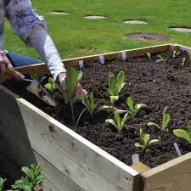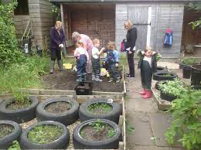
Summer 1 | 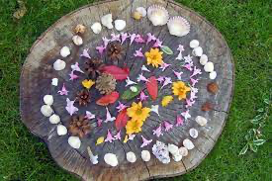  Project – Spots and Stripes - In this project children will: Learn about the different types of materials found in forest school and how these can be used to make natural art based on their textures, colours, shapes and properties.  Lesson 1: Identify and collect different materials around forest school. Name each type and talk about the different colours, textures, shapes etc.  Deeper: Understand that Materials can be shaped or combined to produce different effects.  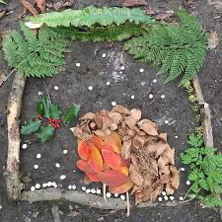  Lesson 2: Plan their piece of art – look at artwork by Andy Goldsworthy using natural materials – are they inspired? Find their items and plan their art.  Deeper: Look for patterns, symmetry and natural features to enhance their piece.  Lesson 3: Build their art piece, using their collected items and record it in photos.  Deeper: Use more than one material to create an effect in their art piece.  Key Vocabulary: log, branch, grass, seeds, flowers, leaves, rocks, stones, art, Andy Goldsworthy.  Key Learning for Children to Remember:  - Artwork can be made using natural resources and pieces they collect. Art does not have to be fixed or painted to be works of art.
Summer 2 | Project – Wonderful Earth - In this project children will: Identify sources of food, harvest, cook and eat their grown foods.  Lesson 1: Maintain their vegetable beds and check to see what has grown, discuss what is ready to harvest and why.  Deeper: Understand that ripe foods are the correct colour and texture – e.g. carrots are orange and firm, tomatoes and soft and red. Etc.  Lesson 2: Harvest fruits and vegetables – how does it look? Are they ripe? Collect and explore what they have harvested.  Deeper: Sort into fruits/vegetables which are good for cooking? Which should we eat raw?  Lesson 3: Chopping and cooking your food around the campfire – can you make your harvest into a soup? (Fire must be made/used by Level 3 Forest School Leader (JW/GW)).  Deeper: Understand how the herbs can enhance the flavour of the food by adding different layers of flavour. Taste the difference.  Key Vocabulary: raw, cooked, soft, hard, campfire, boil, chop, taste, flavour, enhance, improve.  Key Learning for Children to Remember:  - Fresh foods that we have grown can be harvested and cooked. Fresh fruits and vegetables are good for your body. Unripe foods can make you feel unwell, it is important to check they are ripe.  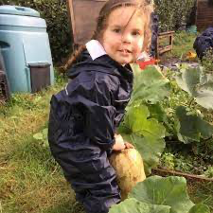  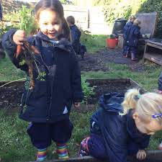
Our Quality of Education - Year 1 – Forest School
Autumn 1 | Unit Overview/Title  Woodland Games.  Defined End Point:  In this unit children will know how to use their senses to explore the area and identify natural/wild items, their names and their features. | 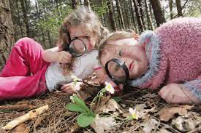  Lesson 1: (Reinforce previously learned rules)  - No pick – anything alive must be left to grow;  - No lick – things in Forest School can make you feel unwell; it is important to never put your hands or anything else in your mouth;  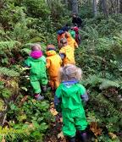  - Stay clear of the fire circle – we must walk around the outside of the fire circle even when there isn’t a fire as it is safest to assume that a fire could be burning at any time and it is safest.  - Identify each of your senses and the corresponding body parts.  - Discuss how we can use sight, hearing, touch and smell while in Forest School, but not taste unless we have a planned tasting session with washed hands – link to ‘no lick’ rule.  - Discuss each of the areas of the paddock, how to explore safely – are there any places we could be quiet? Any places best for smell? (herb garden area).  - Walk around the whole of the paddock, being mindful not to disturb any wild creatures by being too noisy, look for things you notice using your senses.  - Feedback in the fire circle and discuss using new vocabulary for all to hear and understand.  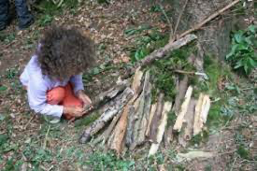  SC: All: I can use my senses to explore Forest School, identify and name different items found in Forest School.  Deeper Learning: I can use new vocabulary accurately.  Lesson 2: (Review rules and previous lesson – what did we discover? Where was it? Was it an animal or something growing?)  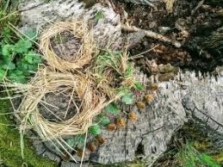  - Play a game of 1,2,3 Where Are You? To warm up and familiarise with the area.  - Introduce game ‘Who Am I?’ using what they discovered last lesson, can children identify the item being described? Adult to model initially giving clues such as ‘it is brown...’, ‘it makes a high pitched sound...’. Finally give a clear clue such as ‘it has a beak.’ and children to guess moving around the paddock to find any evidence of the item, the first person to answer will take the turn.  - Finish with a review of items found and where – why do you think they were found there?  SC: All: I can describe items found in the woodland with their key features.  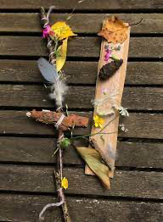  Deeper Learning: I can distinguish between natural objects and those that don’t belong in the woodland.  Lesson 3: (Review rules and previous learning)  - Discuss that today we will make a journey stick. Model collecting a stick and wrapping string around the top to secure.  - Next show how you will take a mindful walk around the paddock, looking at items that take your eye. It these items are not still growing; you can attach them in order to your journey stick to tell the story of your walk around the paddock.  - Allow children time to make their sticks and them complete their own stick.  - Call back to fire circle and discuss your sticks in pairs, then a few to feedback to the whole group.  SC: All: I can identify areas of Forest School by the items found there.  Deeper Learning: I can explain why an item is found in a particular area of Forest School (growth conditions). | Key Vocabulary  All: wild, sounds, listen, hear, see, sight, smell, sniff, feel, touch, growth, living, safe, danger.  Deeper learning: noise, watch, scent, texture. | Previous Learning: Rules of Forest School.  Retrieval Ideas: What are the five senses?  Possible Home Learning: Exploring their garden/the park for similar or different items.  Resources: Waterproofs and wellies, sun hats/sun cream, first aid kit, water string.
Autumn 1 | Key learning for children to remember:  - All natural items have a preferred area to grown and survive.  - Different items need different conditions and will be found in separate areas.  - Some items do not belong in the woodland – these are left by people, links to littering.
Autumn 2 | Unit Overview/Title  Knots and Structures  Defined End Point:  In this unit children will learn how to secure sticks with different knots to make secure structures. | 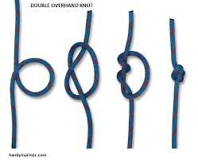  Lesson 1: (Review rules of Forest School)  - Recap work on shelters from Reception – what do we remember?  - Introduce how we will be tying knots to make our own structures that will be able to hold an item.  - Model tying the overhand knot and how it will secure around a piece of wood/stick/two sticks.  - Chn to practice, giving individual support where needed.  - Chn to display their work for all. Individual feedback and support.  SC: All: I can tie an overhand knot (p1 of guidance booklet).  Deeper Learning: I can use the knot to secure two sticks.  Lesson 2: (Review rules and how we will be tying knots to make our own structures that will be able to hold an item.)  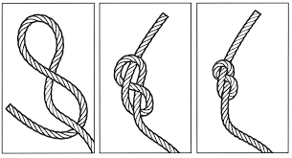  - Model tying the figure of eight knot and how it will secure around a piece of wood/stick/two sticks.  - Chn to practice, giving individual support where needed.  - Chn to display their work for all. Individual feedback and support.  SC: All: I can tie a figure of eight knot (p1 of guidance booklet).  Deeper Learning: I can use the knot to secure three pieces of wood.  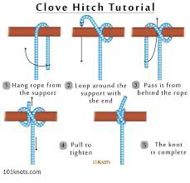  Lesson 3: (Review rules and how we will be tying knots to make our own structures that will be able to hold an item)  - Model tying the clove hitch knot and how it will secure around sticks to make a structure.  - Chn to practice, giving individual support where needed.  - Chn to display their work for all, test with teddy – can it hold the weight?  SC: All: I can tie a clove hitch knot p2 of guidance booklet).  Deeper Learning: I can use the knot to make a simple structure that will hold a teddy. | Key Vocabulary  All: string, rope, tie, loop, pull, tuck.  Deeper learning: secure, test, structure. | Previous Learning: Materials used for shelters in Reception.  Retrieval Ideas: What are the names of the three knots?  Possible Home Learning: Use the knot to secure sticks in your garden/the park.  Resources: String, scissors, waterproofs, wellies, first aid kit, water.
Autumn 2 | Key learning for children to remember:  - Knots are used to secure sticks and wooden pieces in the woodland to make safe structures.  - Knots needs to be tied correctly to work properly.  - It is important to check your knot is tied tightly so that it is secure.
Spring 1 | Unit Overview/Title  Fire lighting – must be delivered by Level 3 forest school leader (JW/GW)  Defined End Point:  In this unit children will learn how to make a safe area for a fire, how to use tools to make a spark and how to make their own fire lighters to light a small camp fire. | 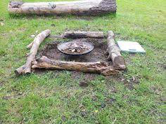  Lesson 1: (Review forest school rules)  - Introduce how we will be making our own camp fires safely.  - Discuss how to be safe – not having overgrowing items, long grass, litter etc in the area, clear from trees and items that could accidentally catch fire.  - Ask chn to identify potential dangers around our camp fire area and relocate them.  SC: All: I can create a safe fire pit area.  Deeper Learning: I can spot dangers ahead of time and make plans to manage these risks.  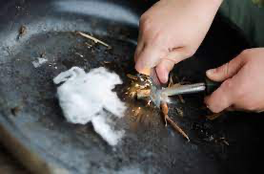  Lesson 2: (Review forest school rules and previous learning)  - Introduce how we will be using flint and steel to make sparks – this is how we light our fires.  - Discuss how to be safe – model how to use the flint and steel and how we direct the spark into the pit to be safe, hair tied back, gloves off and kneeling safely.  - Ask chn to make their own sparks.  SC: All: I can use tools to make a spark.  Deeper Learning: I can direct my spark to the safest place.  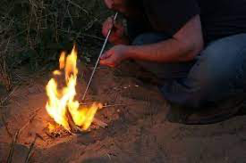  Lesson 3: (Review previous learning and forest school rules)  - Discuss how we will be making our own camp fires today – what di we need to do? Safe area, water to put out fire, flint and steel for sparks and safe posture, flammable items stored away from the fire pit – how to keep ignitable materials safe.  - Model how to make your own fire lighter using Vaseline and fluffed up cotton pads on the sticks.  - Chn to collect own sticks and make own firelighter, light with flint and steel.  SC: All: I can use tools and firelighters to make a small and controlled camp fire.  Deeper Learning: I can arrange my sticks to make an effective camp fire. | Key Vocabulary  All: flint, steel, spark, safe, fire.  Deeper learning: direct, aim, strike, flammable, ignite. | Previous Learning:  Using the fire to cook in Reception.  Retrieval Ideas: how to make a fire area safe.  Possible Home Learning: Ways to make a safe camp fire area.  Resources: Wellies, waterproofs, first aid kit, water, buckets of water,
Spring 1 | Key learning for children to remember:  - Fire is dangerous and can quickly become out of control.  - We can make it safer by clearing the area of easily burned items, having water in case of emergencies and storing the flammable materials away from the fire pit.  - Fires need to be watched all of the time and must be put out carefully.  - Hot spots can burn for hours after a fire has been put out.
Spring 2 | Unit Overview/Title  Food and growing  Defined End Point:  In this unit children will learn how to make and prepare vegetable growing beds, effective seed sowing and plant care. | 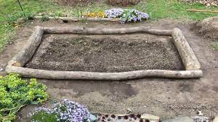  Lesson 1: (Review previous learning on growth and forest school rules)  - Discuss how we will be working on making our own vegetable beds to grow vegetables and herbs.  - Talk about what natural resources we have to help us – big logs, sensible places to plant – lots of sunlight.  - Model using the logs to build beds, filling with soil and settling the soil.  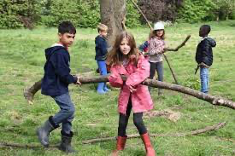  - Chn to make own beds in groups.  SC: All: I can use resources to make a vegetable bed.  Deeper Learning: I can identify the best place for seeds and plants to grow.  Lesson 2: (Review previous learning making vegetable beds and forest school rules)  - Discuss how today we will need to plant our seeds – what is the best way to do this? Agree on spacing out and ensuring that each plant has space to grow.  - Chn to plant out seeds and begin to care for them with water.  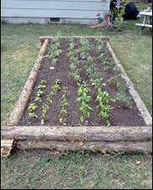  - Label the seeds with markers so that we know what is growing and where.  SC:  All: I can plant seeds and take care of them.  Deeper Learning: I can understand that seeds need different level of care and should be treated differently.  Lesson 3: (Review previous learning making vegetable beds, planting seeds and forest school rules)  - Discuss how we now need to look after our seeds. What do we need to do?  - Talk about sunlight, water and checking the area for debris that will make growth difficult.  - Chn to check area, water seeds and monitor for growth.  - Agree on a schedule to take care of the seeds – once a week watering will not make them grow.  SC: All: I can provide seeds with all they need to grow.  Deeper Learning: I can monitor the growth of seeds and tailor care accordingly. | Key Vocabulary  All: seeds, soil, sunlight, growth, grow, sprout, roots, shoots, leaves, stem, crops, water, vegetable, herb, predator.  Deeper learning: care, maximise, | Previous Learning: Link to growth in Reception.  Retrieval Ideas: What does a plant need to grow?  Possible Home Learning: growing own plants at home.  Resources: logs, soil, vegetable seeds, watering cans, herb seeds, trowels, mini forks.
Spring 2 | Key learning for children to remember:  - Plants all need different conditions to grow best.  - Some plants need lots of water, others need less.  - Seeds need watering if there is not any rain.  - Plants need a clear area in their bed to grow best.
Summer 1 | Unit Overview/Title  Tools - must be delivered by Level 3 Forest School Leader (JW/GW).  Defined End Point:  In this unit children will learn that tools need to be used safely to ensure that they do not hurt us or others. | 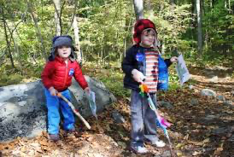  Lesson 1: (Review rules of forest school)  - Talk about how we will use our vegetables to make a roasted vegetable kebab and so will need to make our own kebab sticks.  - Review stick safety – held in hand, pointed down and walking with it.  - Chn to practice.  - Now discuss finding a clean and suitable stick for kebab sticks – not splintered or dirty.  - Chn to explore paddock for suitable sticks for collection.  SC: All: I can carry sticks safely, following safety rules.  Deeper Learning: I can spot dangers ahead of time and act to stop injury.  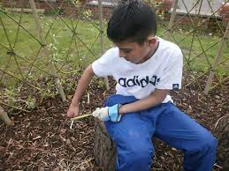  Lesson 2: (Review previous learning about stick safety and forest school rules.)  - Discuss how today we will be using potato peelers to peel the bark from some wood.  - Model use of potato peelers starting close to you and moving away with care and control. Discuss how we need to keep the peeler away from our fingers as it has a blade.  - Chn to practice using the peelers to peel the bark from wood.  SC: All: I can use tools safely, following safety rules.  Deeper Learning: I can manage risks and keep myself and others safe.  Lesson 3: (Review previous learning about stick safety and forest school rules)  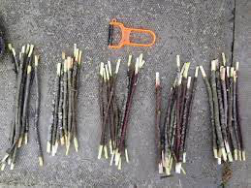  - Discuss how today we will be using potato peelers to make our kebab sticks.  - Re-model use of potato peelers starting close to you and moving away with care and control. Discuss how we need to keep the peeler away from our fingers as it has a blade.  - Model making the kebab stick – peeling the bark from the length of stick to be clean and making a point at the end to skewer the vegetables.  - Chn to make own kebab sticks.  SC: All: I can use tools safely, following safety rules.  Deeper Learning: I can manage risks and keep myself and others safe. | Key Vocabulary  All: safe, away from you, rules, use, handle, careful.  Deeper learning: | Previous Learning: flint and steel use for lighting fires.  Retrieval Ideas: How do we stay safe around tools?  Possible Home Learning:  Resources: potato peelers, wellies, waterproofs, first aid kit, water, water bottles, sun htas/cream
Summer 1 | Key learning for children to remember:  - Sticks are dangerous and can hurt you or others if carried incorrectly.  - Sticks need to be carried pointing down, by your side and you must walk.  - Potato peelers have blades and should be used with care.
Summer 2 | Unit Overview/Title  Harvest and enjoy our vegetables – lesson 3 must be delivered by Level 3 Forest School Leader (JW/GW).  Defined End Point:  In this unit children will learn how to check their food has grown and ripened sufficiently, how to harvest their produce and prepare/cook for eating. | 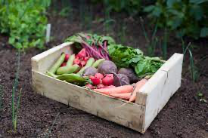  Lesson 1: (Review previous learning on forest school rules and fire safety, what have we been learning about in forest school in the last two terms?)  - Discuss how we have been growing vegetables and herbs – now it is time to check them.  - Model how to check the produce is ready – gently lifting root veggies, checking the colour, size and shape – could have printed pictures to help decide if they match?  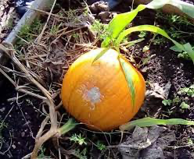  - Chn to check for readiness and harvest.  SC: All: I can check for signs of ripeness in vegetables.  Deeper Learning: I can compare vegetables to check for readiness.  Lesson 2: (Review previous learning on forest school rules and food harvest.)  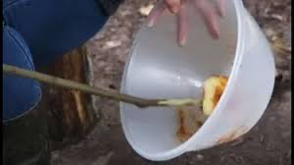  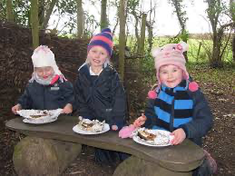  - Discuss how we need to prepare our vegetables for roasting on the fire – tool talk for peelers (review) and knife work (chopping) Model these in an outdoor context using chopping board, damp tea towel to hold board in place at the table to make sure that the tools are less likely to slip.  - Look at different ways to prepare the vegetables – peeling and chopping.  - Chn to practice preparing vegetables and placing in cold water to keep fresh.  SC: All: I can use tools to prepare vegetables for eating.  Deeper Learning: I can choose the best way to prepare my vegetables to eat, keeping the sizes similar to cook evenly.  Lesson 3: (Review previous learning on forest school rules and food harvest/prep)  - Discuss how we now need to cook our vegetables ready to eat – this means putting them on skewers and brushing with oil/seasonings.  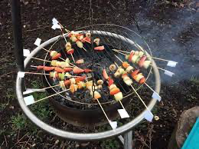  - Model how to make own kebab stick, then cook on the fire in foil to minimise the cooking time.  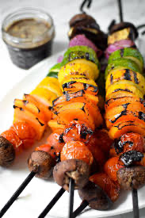  - Chn to prep own kebab sticks and brush with oil/seasonings and cook with supervision.  - Check food is ready and eat.  - Review growing, tool use, fire and food prep from the last two terms – what do we remember? What have we enjoyed? What would we include/not include if we did it again?  SC: All: I can make, cook and evaluate my roasted vegetable kebab.  Deeper Learning: I can share ideas of how I would improve my work. | Key Vocabulary  All: harvest, ripe, check, grown, growth, ready, prepare, peel, chop, cook, fire, flames,  Deeper learning: produce, roast, seasoned | Previous Learning: work on fire in spring 1, growing in spring 2 and making kebab sticks in summer 1.  Retrieval Ideas: how do we help plants to grow? What can we do to keep safe with tools? How do we make sure our fire pit is safe and ready?  Possible Home Learning – tasting different vegetables, exploring vegetables when shopping.  Resources: vegetables, pictures veggies for comparison, oil, seasoning – pre-grown herbs, kindling, flint and steel, cotton pads, Vaseline, water, first aid kit, kebab sticks.
Summer 2 | Key learning for children to remember:  - Food prep can be done outdoors safely, on a table or safe surface.  - Harvest needs to be done when foods are ready.  - Vegetables can be roasted in oil to cook quicker.

Our Quality of Education - Year 2 – Forest School
Autumn 1 | Unit Overview/Title  Games  Defined End Point:  In this unit children will access a range of more safety demanding games, expecting children to plan ahead and be more aware of others and the possible dangers within the paddock. | 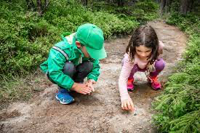  Lesson 1: Reinforce previously learned rules –  - No pick – anything alive must be left to grow.  - No lick – things in Forest School can make you feel unwell, it is important to never put your hands or anything else in your mouth.  - Stay clear of the fire circle – we must walk around the outside of the fire circle even when there isn’t a fire as it is safest to assume that a fire could be burning at any time, and it is safest.  - Recap games chn recall from prior sessions – 1, 2, 3, Where Are You? Journey Sticks etc.  - Introduce new game – What Am I? Children will take a short walk around the paddock, looking at what is growing, fallen, living and moving in the area at all levels.  - Return to the campfire area and ask children to spend a moment remembering what they saw. After this, you can model giving clues to an object or item that you saw in three clues– e.g. Clue 1 - I saw something brown... Clue 2 – it was short and spiky... Clue 3 – it fell from the pine tree... Chn should be able to guess that it was a pinecone. Spend some time asking children to share their findings.  SC: All: I can identify and describe features of natural items.  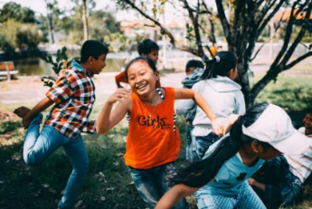  Deeper Learning: I can use a range of adjectives to describe natural items.  Lesson 2: (Review rules of Forest School)  - Recap last session – we were describing items we found. This week we will be playing a more active game – capture the flag!  Capture The Flag -Divide your group into two teams, the paddock into two areas and give each a different coloured flag. They need to assign a Flag Guard to protect their flag from at least 5 paces away. The goal is to catch the flag of the other team. If someone from the other team comes into your territory, you can tag them and put them in your prison where they are guarded by a Prison Guard from at least 5 paces away. You can be freed if a teammate manages to tag you whilst in prison. If one team is particularly good and ends up jailing most of the opposition, an adult can shout ‘jailbreak’ and all prisoners are free and everyone is immune from tagging for 5 seconds!  SC: All: I can join in with team games safely.  Deeper Learning: I can use planning ahead strategies to capture the flag.  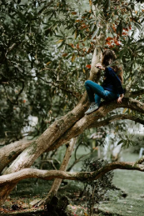  Lesson 3: (Review rules and previous games)  - Introduce a new game that will take some planning – Floor is Lava.  Floor is Lava - Prepare children with the rules for this game – we will take a walk around the paddock, looking at the changes taking place through the beginning of autumn. An adult will shout ‘Floor is Lava in THREE, TWO, ONE’…at which point the floor becomes lava and they need to be off the ground – whether that’s up a tree, standing on a bench, perching precariously on a stump or balancing on a rock – they need to be not touching the ground to avoid being out. When you shout ‘FLOOR IS SAFE’ they can return to the ground and resume moving around the paddock until you shout again. Last one left standing, wins!  SC: All: I can climb safely.  Deeper Learning: I can move whilst being aware of others, plan my target area and climb/land with safety. | Key Vocabulary  All: natural items such as grass, comes, plants, sticks, birds.  Adjectives to describe such as colours, textures – soft, smooth, rough, spiky, sharp, crumbly.  Branch, stem, twig, leaf, root, fruit, blossom, trunk.  Team, tag, flag, area, protect, lava, safe, danger, climb.  Deeper learning:  More technical vocabulary such as pinecone, seed pod, territory, | Previous Learning: Games in previous years – e.g. 1, 2, 3, Where Are You? And Journey Sticks in Year 1.  Retrieval Ideas: What are three words you can use to describe...  How did the tree/plant grow here?  Possible Home Learning – Nature walks to spot other natural items or finding similar items and comparing locations.  Resources:  Waterproof trousers, wellies, coat, first aid kit, water.
Autumn 1 | Key learning for children to remember:  - Moving around forest school can be dangerous and we need to be aware of our surroundings.  - Team games are an important way to build friendships and trust.
Autumn 2 | Unit Overview/Title  Knots  Defined End Point:  In this unit children will learn that knots alone can be strong enough to hold a structure that can bear weight. Structures can be made from natural resources and we can test our work and adjust to improve it. | 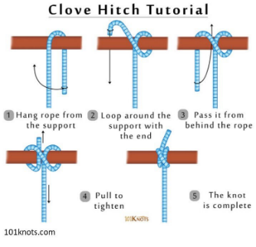  Lesson 1: (Review rules of Forest School)  - Review knots previously taught – overhand and figure of eight knot.  - Introduce that we will learn a more complicated knot today used to secure logs and branches to make structures. We will use these to make a structure that can support the weight of one of us.  - Give each person a piece of string, their own found stick and model the process.  - Allow chn time to work on this and make mistakes, self-correct and perfect.  - When they have this, chn can now practice tying their knot around items in the paddock to secure.  SC: All: I can tie a clove hitch knot.  Deeper Learning: I can explain how a clove hitch knot works to secure items.  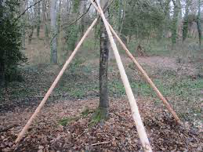  Lesson 2:  - Review rules and previous learning.  - Recap tying the clove hitch to a stick. This week we will tie the clove hitch around two or three sticks to secure them in a tent frame shape. We will work in groups to make a frame.  - Chn to collect two to three large sticks and work to secure their frame using the clove hitch.  SC: All: I can secure a frame using a clove hitch.  Deeper Learning: I can use binding techniques to secure the ends of my knot and prevent slipping.  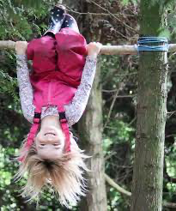  Lesson 3:  - Review forest school rules and clove hitch knot to secure a frame.  - This week we will check/re-secure our frames and add in supporting structures along the bottom to hold the weight of a person.  - Allow time for children to work on their structures and placement of supporting branches – ensure these are off the floor!  - When complete, test the supporting structure by allowing one person to test standing carefully on the branch, gradually adding more of their weight until they are completely off the floor.  - How strong is your structure? How many people can it hold?  - Return all branches to original places.  SC: All: I can use knots to make a self-supporting structure.  Deeper Learning: I can test my structure and make adjustments were needed to improve. | Key Vocabulary  All: knot, clove hitch, overhand, figure of eight, branch, tie, structure, support, strong, secure, tight.  Deeper learning:  Adjust, improve, bear weight. | Previous Learning: overhand and figure of eight knots in Year 1.  Retrieval Ideas: How to tie clove hitch, uses of clove hitch knots, how to secure branches using clove hitch knots.  Possible Home Learning – practice of tying the clove hitch knot.  Resources: string/rope, large branches, waterproofs, wellies, first aid kit, water.
Autumn 2 | Key learning for children to remember:  - Knots are tricky and tying them must follow the correct order to work.  - Self-supporting structures can hold the weight of a person.
Spring 1 | Unit Overview/Title  Fire Lighting – must be delivered by Level 3 Forest School Leader (JW/GW).  Defined End Point:  In this unit children will learn how to build an effective fire pit area, how to make an effective fire and how to ensure it is properly extinguished. | 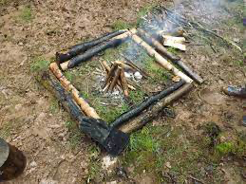  Lesson 1: (Review forest school rules)  - Look over the previous learning children from Year 1 – making sparks and making fire lighters using cotton wool and Vaseline.  - Discuss how to make the safest fire pit.  - This week we will prepare the fire pit area – what should we do? Discuss overhanging branches, things that could fall, rolling the log seats, how far away the log seats need to be.  - Recap using the flint and steel to make sparks, chn to practice.  SC: All: I can prepare a safe area for a campfire.  Deeper Learning: I can discuss the safest spot for a campfire, I can minimise risks when having a fire.  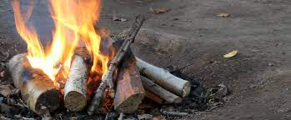  Lesson 2: (Review forest school rules and fire safety)  - This week we will look at how to build an effective fire – it's not just stacking sticks and lighting it!  - Discuss how we need to use dry wood, starting with the smallest twigs that burn quickly to begin the fire and layer it so that the wood is bigger on each layer up to big blocks of wood that will burn for a long time.  - Chn to collect different twigs, sticks and branches – sort into sizes and arrange to dry for their next session.  SC: All: I can understand that fires have to be prepared to be most effective.  Deeper Learning: I understand that the smallest twigs begin the fire and enable the larger wood to burn for longer using their heat.  Lesson 3: (Review forest school rules)  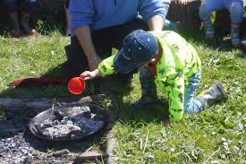  - Recap building a fire using smallest to largest wood.  - Discuss extinguishing safety – fires burn very hot so even if there is no flames left, the ground can be very hot. This can lead to hot spots – travelling heat that can make other fires elsewhere in forest school – why might this be dangerous?  - Look around for danger areas and discuss how we must always make sure our fires are put out properly using lots of water as we only use wood for fuel and we must always check back for hot spots.  - Chn to prepare a fire in groups in the pit, building up. Light when finished.  - Allow to burn for a little while, then use water to put out – discuss how there is lots of smoke as the heat is very quickly dropping the temperature.  - Play a game of 1, 2, 3, Where Are You? To allow the ground to cool off – return to check for hot spots.  SC: All: I can ensure a fire is properly extinguished.  Deeper Learning: I can check for hot spots and signs that a fire is spreading. | Key Vocabulary  All: fire, campfire, kindling, twigs, branches, fire and steel, fire lighter, flame, smoke, light, extinguish, build.  Deeper learning: build-up for best fire building, hot spots. | Previous Learning: fire lighting using flint and steel in Year 1. Checking area for dangers in Year 1.  Retrieval Ideas: How to make a fire lighter using cotton wool and Vaseline.  Possible Home Learning – research fire safety.  Resources:
Spring 1 | Key learning for children to remember:  - We need to build up our fire using the smallest wood up to the largest wood to enable it to burn most effectively.  - Fires can spread very easily.  - We need to use lots of water to extinguish a fire and must check for hot ground/spots to make sure it is out fully.
Spring 2 | Unit Overview/Title  Planting and Growing  Defined End Point:  In this activity children will learn that some plants help others to grow because they take away harmful things from the soil or encourage wildlife that help them to grow. They will learn that plants need pollinators to ensure that they continue to grow and produce flowers/fruit. | 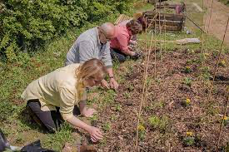  Lesson 1: (Review forest school rules)  - Recap prior learning on preparing vegetable beds and plant growth.  - Discuss how we will be preparing our vegetable beds once again, but this time we need to allow for companion planting – this is where we pair up different plants to give then the best chance of growing the best crop because they create a better environment by removing toxins from the soil for each other (food for one is toxic for the other) or they encourage more pollinators to encourage the growth of crops (such as flowering plants).  - Model how to prepare the beds by having a ‘double row’ of planting areas for the pairs of plants.  - Chn to prepare beds.  SC: All: I can prepare the growing area for companion planting.  Deeper Learning: I can understand why companion planting is important for the best crop environment.  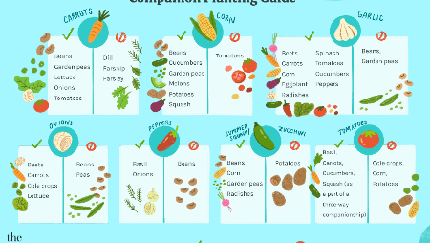  Lesson 2: (Review forest school rules vegetable bed prep from last session)  - This session we will plant seeds in companion pairs – use the guide to choose which seeds should be paired for the best crops.  - Children will spend this time planting the pairs and labelling what is growing there.  SC: All: I can pair plants to maximise their growth chances.  Deeper Learning: I can pair plants with a range of companion plants to create the best growing environment.  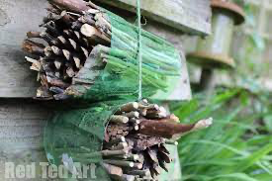  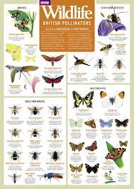  Lesson 3:  - Review forest school rules and companion planting work.  - Now we need to encourage pollinating insects into the area to help spread the pollen and enable the plants to flower – the pollen from one plant is carried either by the wind or pollinating insects to another plant to enable the plant to grow fruit.  - Which pollinating insects do we know?  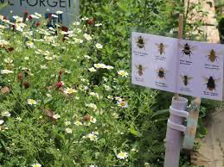  - Use the guide to look for different pollinators.  - Discuss how we can make bug homes for them in our vegetable beds like the leaf wrapped ones in the picture.  - Place the finished bug homes in their vegetable beds and label with images of the types of pollinators they expect to find:  SC: All: I can  Deeper Learning: | Key Vocabulary  All: seeds, soil, sunlight, growth, grow, sprout, roots, shoots, leaves, stem, crops, water, vegetable, herb, predator, companion planting, encourage, environment, habitat  Deeper learning: care, maximise, pollinators, | Previous Learning: Planting and growing individual vegetables in Year 1.  Retrieval Ideas: Plant life cycles, effects of pollinators in crop growth.  Possible Home Learning  Resources:
Spring 2 | Key learning for children to remember:  - Companion planting encourages the best growth of crops.  - Pollinators are crucial to ensure that plants grow crops.
Summer 1 | Unit Overview/Title  Tools – must be delivered by Level 3 Forest School Leader (JW/GW).  Defined End Point:  In this unit children will learn how to manage the safety of bladed tools, how to care for the tools when not being used. | Lesson 1: (Review forest school rules and previous work on using potato peelers safely in forest school.)  - Introduce the next tool that children will use – a pen knife. It is important that we always care for our tools, using the same method each time.  - Show the pen knife in its lidded box – why do you think we keep it in here? Discuss safety and how the blade is very sharp. The box protects the blade and us from damage/getting hurt. Today we are going to learn how to care for the blade to make sure it is always safe – a sharp blade is safer than a blunt blade as it doesn’t harbour bacteria like a blunt one.  - Open the box and show the knife – how to open the blade to use from being safety locked.  - Model how to sharpen the blade using the sharpening block in long strokes on both sides. Use the oiled cloth to clean the fragments and check for smooth, clean blades. Now close it up safely and lock in place. Replace the knife in the box.  - Chn to sharpen and clean own blades, two at a time as shown.  SC: All: I can care for tools and store them safely.  Deeper Learning: I can understand why a sharp blade is safer than a blunt blade.  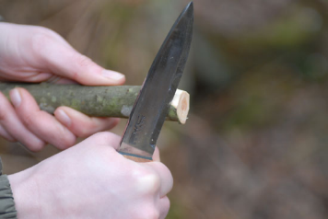  Lesson 2: (Recap forest school rules and blade care – retrieval questions of how to ensure the blade is safely locked in position before using)  - This week we will use the blades to carve sticks – like we did with potato peelers last year. Model how to open and lock the blade in place again.  - Model how to hold a stick at one end with a safety glove on that hand – no glove on the tool holding hand (safety so it doesn’t slip). Now show how to slice the wood using the blade away from you as if sharpening the end.  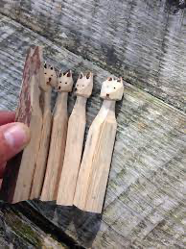  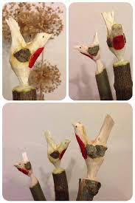  - Chn to practice this, then follow the blade cleaning and safe practice of returning the knife to the toolbox. Adult to collect back in and count.  SC: All: I can use a knife safely to cut wood.  Deeper Learning: I can understand why a glove on my tool bearing hand can make working unsafe.  Lesson 3: (Review forest school rules and tool safety/use from previous session)  - Explain that this week we will use the knife and potato peelers to whittle – forest animals!  - Share pictures of what these could look like to give ideas.  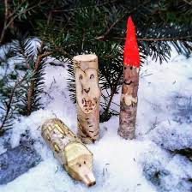  - Model – once again using the locking mechanism for blade safety and gloved hand on the non-tool bearing hand – how to whittle a simple fox with pointed ears (first picture) and adding the details on with natural paint from the mud kitchen.  - Chn to whittle their own animals.  - Tool/blade care (sharpening, cleaning, oiling and returning to safety box).  SC: All: I can use tools to make a sculpture.  Deeper Learning: I can plan my sculpture and make simple cuts to carve shapes. | Key Vocabulary  All: knife, sharp, dull, blunt, safety, locked, toolbox, oil, clean, sanding block, carve, away from the body, whittle, sculpture  Deeper learning: protect, gauntlet | Previous Learning: ue of potato peelers to whittle kebab sticks in Year 1.  Retrieval Ideas: What is the safety procedure to open a knife? Clean a knife?  Possible Home Learning – uses of whittling.  Resources: first aid kit, safety gloves, water, waterproofs, wellies, tools (pen knives in locked tool box, oiled cloths, sharpening block.
Summer 1 | Key learning for children to remember:  - Knives must be cared for to keep them safe.  - Whittling must be done by pushing the tool away from you while wearing a safety gauntlet.  - We can make decorative and everyday items using whittling.
Summer 2 | Unit Overview/Title  Food Harvesting and Cooking – Lesson 3 must be delivered by Level 3 Forest School Leader (JW/GW).  Defined End Point:  In this unit children will learn to harvest and wash companion planted crops when ripe, prepare them using food processing skills, cook them using a recipe for eating. | 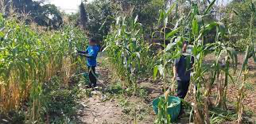  Lesson 1: (Review forest school rules, previous work on companion planting and harvest (in year 1).  - Discuss how this week we will check our crops and carefully harvest them.  - Model how to harvest each of their crops – cutting, digging up etc.  - Chn to harvest and wash their crops ready for storage.  SC: All: I can check crops for ripeness and harvest them.  Deeper Learning: I know there are different ways to harvest different crops.  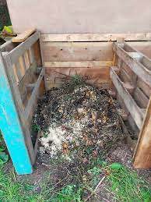  Lesson 2: (Review forest school rules and previous work on harvesting)  - Discuss how this week we need to clear and prep our vegetable beds for a rest over winter so we can grow in them again next year.  - Model clearing out the remaining leaves/stalks and plant debris of those plants, making use of the waste by composting.  - Chn to prepare the beds and compost waste.  SC: All: I can prepare vegetable beds for winter.  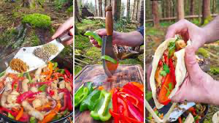  Deeper Learning: I know that ground needs to rest properly (fallow) to grow crops.  Lesson 3: (Recap forest school rules, harvesting, composting and cooking vegetable kebabs (in year 1).  - Explain that today we will prep and cook our own harvest, making them into vegetable fajitas.  - Model prepping the vegetables, using seasonings to taste.  - Build, light and cook the vegetables on the campfire (either in wraps with foil wrappings or in a pan and construct after).  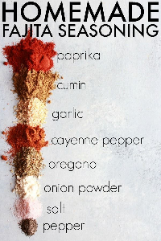  - Check food is adequately cooked.  - Chn to wild handwash.  - Enjoy your fajitas around the campfire.  SC: All: I can prepare vegetables and seasonings and cook them using a recipe.  Deeper Learning: I know that foods need to be similar sized to cook evenly. | Key Vocabulary  All: harvest, ripe, check, cut, crops, wash, store, fridge, refrigerate, chop, fry, roast, season, cooked, cook, taste, compost, rot, prepare.  Deeper learning: fallow, nutrients, harvest season. | Previous Learning: harvest and roasting vegetables in year 1.  Retrieval Ideas: how to process food – knife safety.  Possible Home Learning – recipes for fajitas.  Resources: vegetables, trowels, knife, bucket, water to wash, water for first aid, first aid kits, composting area, knife and chopping board, fajita seasoning, wraps (gluten free/allergy friendly options too), kindling, firelighters, flint and steel, water to extinguish, safety gauntlets.
Summer 2 | Key learning for children to remember:  - Foods are harvested at different times and need to be checked for ripeness.  - Foods cook best when they are similarly sized to ensure they are ready at the same time.  - Vegetable beds need to be prepped for the next growing season.

